

**Assessment Cover Page**

*To be provided separately as a Word doc for students to include with every submission*

|  |  |  |
| --- | --- | --- |
| **Module Title(s):** | Programming for DA  Statistics for Data Analytics  Machine Learning for Data Analysis  Data Preparation & Visualisation | |
| **Assessment Title:** | MSC_DA_CA2 | |
| **Lecturer Name:** | Sam Weiss  John O’Sullivan/Marina Iantorno  Muhammad Iqbal  David McQuaid | |
| **Student Full Name:** | Fatime Reisenleitner | 2020491 |
| **Assessment Due Date:** | Friday 6th January 2023 at 23:59 | |
| **Date of Submission:** | Friday 7th January 2023 | |

**Declaration**

|  |
| --- |
| By submitting this assessment, I confirm that I have read the CCT policy on Academic Misconduct and understand the implications of submitting work that is not my own or does not appropriately reference material taken from a third party or another source. I declare it to be my work and that all material from third parties has been appropriately referenced. I further confirm that this work has not previously been submitted for assessment by myself or someone else in CCT College Dublin or any other higher education institution. |

Table of Contents

Project Planning 4

Project Management Framework 4

Research 8

Data Gathering 8

FAOSTAT 8

Source: 9

Licencing: 9

Dashboard: EU Agri-Food 10

Project Justification & project approach 17

1. Business Understanding 17

Area/Objectives of Research: 17

Situation Assessment 17

Project Challenges 18

Appendix 18

FAOSTAT Licensing 19

FAOSTAT Terms of use 19

FAOSTAT Terms & Conditions 20

Global Reliance on Ukraine 22

Wheat 22

Grains 23

Sunflower Oil 24

**Disclaimer:**

Data sets used in this project are from the official gov.ie website used for educational purposes only.

*Version Control Repository*: https://github.com/2020491/MSC_DA_CA2/upload/main

# Project Planning

* Timelines
  + GANTT/Asana
* Version Control Software:
  + GitHub/Gitlab/BitBucket

# Project Management Framework

**Choosing the Right Management Framework**

Before embarking on a journey in the form of a data analysis project, it is essential to consider the various project management frameworks available and which one is most suitable for the project at hand.

The most popular options include KDD, SEMMA and CRISP-DM, each with its own unique characteristics as well as its various pros and cons that will be explored in depth to ensure that the right choice is made for our specific project.

1. **Knowledge Discovery in Database (KDD)**

The KDD process was developed in 1989 with the aim of purging the data set of outliers while deriving useful patterns and trends that can add valuable insight to the researcher (Hotz, 2021).

**Steps of KDD**:

1. **Selection**: finding a database of relevant information and determining the variables to be used.
2. **Pre-Processing**: cleaning the data which leads to an improvement in the overall quality of the data.
3. **Transformation**: converting the data to a usable format where information is organised and sorted.
4. **Data Mining**: analysing the data to identify patterns and trends which are graphed and charted in a useful way.
5. **Interpretation/Evaluation**: interpreting and documenting the findings from the data analysis.

**Pros of KDD**:

1. **Market Forecasting**: predicting customer trends and identifying where resources should be allocated.
2. **Iterative Process**: continuous improvement by looping back results from previous stages to the start of the cycle.
3. **Anomaly Identification**: utilising the knowledge of the process to guard against holes and vulnerabilities.

**Cons of KDD**:

1. **Outdated**: having been developed decades ago, this model is ill-equipped for some of the modern challenges.
2. **Expensive**: storing massive amounts of data for continuous improvement can be a costly endeavour.
3. **Vulnerability**: collecting and storing customers’ data means that a security risk presents itself in need of mitigating.
4. **Privacy**: users place higher emphasis on their privacy which makes it more difficult for companies to collect data.
5. **Time**: with continuous improvement engraved in this model, the process is never over.
6. **Waterfall**: following a step-by-step process may lead into rigidity and sluggishness in teams.

<https://www.datascience-pm.com/kdd-and-data-mining/>

1. **Sample, Explore, Modify, Model and Assess (SEMMA)**

The SAS Institute developed SEMMA as a method of data mining with 5 steps that can be used to solve a number of business problems. Data collected by businesses is used to build a foundation for hypothesis and models to understand the world better, but data is useless until it is analysed (Hotz, 2021).

**Steps of SEMMA**:

1. **Sample**: choosing a subset of the appropriate volume dataset and identify variables that influence the process.
2. **Explore**: studying interconnected relationships between data elements and identify gaps in the data.
3. **Modify**: cleaning data and exploring whether the data requires refinement and transformation.
4. **Model**: applying data mining techniques to produce a model of how the data achieves the desired outcome.
5. **Assess**: evaluating the usefulness and reliability of the model for the studied topic.

<https://www.datascience-pm.com/semma/>

1. **Cross-Industry Standard Process for Data Mining (CRISP-DM)**

The CRISP-DM process was developed in 1999 with the aim to standardise data mining processes across industries and has become the most common technique for data analytics projects.

**Steps of CRISP-DM**:

1. **Business Understanding**: understanding the objectives and requirements of the project.
2. **Determine Business Objectives**: understanding customers’ wants and defining business success criteria.
3. **Assess Situation**: determining resource availability and project requirements, while assessing risks.
4. **Determine Data Mining Goals**: defining what success looks like from a technical perspective.
5. **Produce Project Plan**: selecting tools to be used and defining plans for each phase of the project.
6. **Data Understanding**: identifying, collecting and analysing the data sets that will accomplish the project goals.
7. **Collect Initial Data**: acquiring the necessary data and uploading it to the analysis tool to be used.
8. **Describe Data**: examining the data and documenting its properties (e.g. data format and identities).
9. **Explore Data**: querying and visualising the data, while identifying relationships.
10. **Verify Data Quality**: documenting any quality issues with the data.
11. **Data Preparation**: preparing the data set for modelling.
12. **Select Data**: determining the data sets to be used and documenting reasons for their inclusion.
13. **Clean Data**: correcting, imputing and removing erroneous values to ensure that clean data is used.
14. **Construct Data**: deriving new attributes that will be helpful in our analysis of the data.
15. **Integrate Data**: creating new data sets by combining data from multiple sources.
16. **Format Data**: reformatting data may be necessary in some instances.
17. **Modelling**: building and assessing various models based on different modelling techniques.
18. **Select Modelling Technique**: determining which algorithms to use (e.g. regression).
19. **Generate Test Design**: depending on the modelling approach, there may be a need to split data.
20. **Build Model**: executing lines of codes (e.g. for the regression model).
21. **Assess Model**: interpreting the model results based on the domain knowledge, success criteria and test design.
22. **Evaluation**: examining which model meets the business needs best and finalising the end phases of the project.
23. **Evaluate Results**: answering questions like whether the model meets the business success criteria.
24. **Review Process**: reviewing the work and summarising findings, while making adjustments where necessary.
25. **Determine Next Steps**: determining whether to proceed to the final stage or initiate new projects.
26. **Deployment**: allowing the customer to access the results of the project.
27. **Plan Development**: developing and documenting a plan for deploying the model.
28. **Plan Monitoring & Maintenance**: developing a monitoring and maintenance plan to avoid future glitches.
29. **Produce Final Report**: documenting a summary of the project with the results from the data analysis.
30. **Review Project**: conducting a retrospective on how to improve on the development of future projects.

Something that the other two processes largely ignore is understanding the needs of the customers and it is difficult to analyse data without taking this vital part into consideration, while this is clearly understood by the CRISP-DM process.

**Pros of CRISP-DM**:

1. **Generalisable**: there is a clear understanding of the data that must be gathered and cleaned from the start.
2. **Common Sense**: used as a go-to method for data analysis projects when project management direction is lacking.
3. **Adoptable**: implementable without the need for a lot of training or organisation.
4. **Right Start**: allows data analysts to understand the business objectives without jumping into the problem blind.
5. **Strong Finish**: the final step addresses an important element of maintenance and operations after the project ends.
6. **Flexible**: the empirical knowledge gathered from previous projects can be filtered into upcoming projects.

**Cons of CRISP-DM**:

1. **Rigid**: the process likely suffers from the weakness of waterfall and rapid iteration.
2. **Documentation Heavy**: documenting each step is a time-consuming process that may slow results being delivered.
3. **Not Modern**: may be lacking some of the challenges facing modern data analysts.
4. **Not Project Management Approach**: assumes individual work or small team, hence not suitable for large projects.

After examining various processes, CRISP-DM is found to be superior to the others. However, although it is worth harvesting its numerous benefits, it is also worth avoiding a couple of downfalls to make the project most successful.

Perhaps the biggest challenge to overcome is spending too much time on the documentation, so it makes sense to be brief and straight to the point. Also, as mentioned the process is slightly outdated, so making use of more modern processes as well is only logical.

<https://www.datascience-pm.com/crisp-dm-2/>

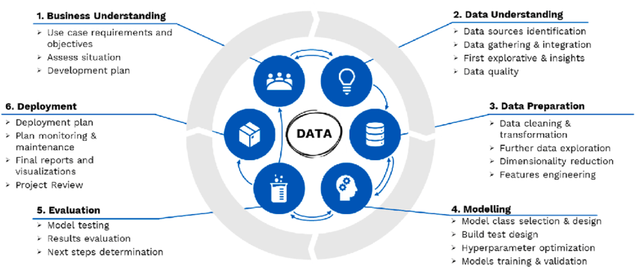

Steps of the CRISP-DM framework, 2022, János Abonyi (<https://www.researchgate.net/figure/Steps-of-the-CRISP-DM-framework_fig1_362363163>)

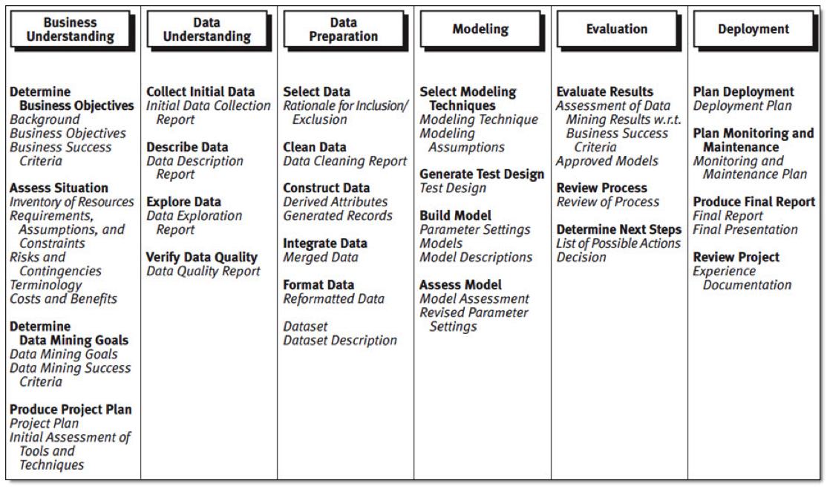

CRISP-DM Methodology, 2022 (http://www.havlena.net/en/business-analytics-intelligence/predictive-analytics-project-in-automotive-industry/)

# Research

The Common Agricultural Policy (CAP) was launched in 1962 in the European Union (EU) to:

1. Improve agricultural productivity and ensuring food security
2. Support farmers to have a reasonable income
3. Maintain rural areas by promoting farming roles

The CAP aims to address the income inequality in the agricultural sector and farmers’ dependence on uncontrollable factors to earn a living by considering:

1. Income support through direct payments to ensure a stable flow of income
2. Market measures to mitigate the risks associate with unexpected declines in demand
3. Rural development measures to address the specific needs of rural areas

The CAP has benefited Europeans in numerous ways:

1. Food production by allowing the 22 million people working in the agricultural sector to produce affordable, quality products.
2. Rural community development by allowing numerous sectors to thrive with their demand for the likes of machinery, buildings, fuel, fertilisers and healthcare, while also directly impacting sectors involved in the preparing, processing, packaging, storage, transport and retail of their food produce.

<https://agriculture.ec.europa.eu/common-agricultural-policy/cap-overview/cap-glance_en>

# Dashboard: EU Agri-Food

On the official EU agridata website (<https://agridata.ec.europa.eu/extensions/DataPortal/home.html>), there are dashboards already created. Below are a step-by-step guide to find them.

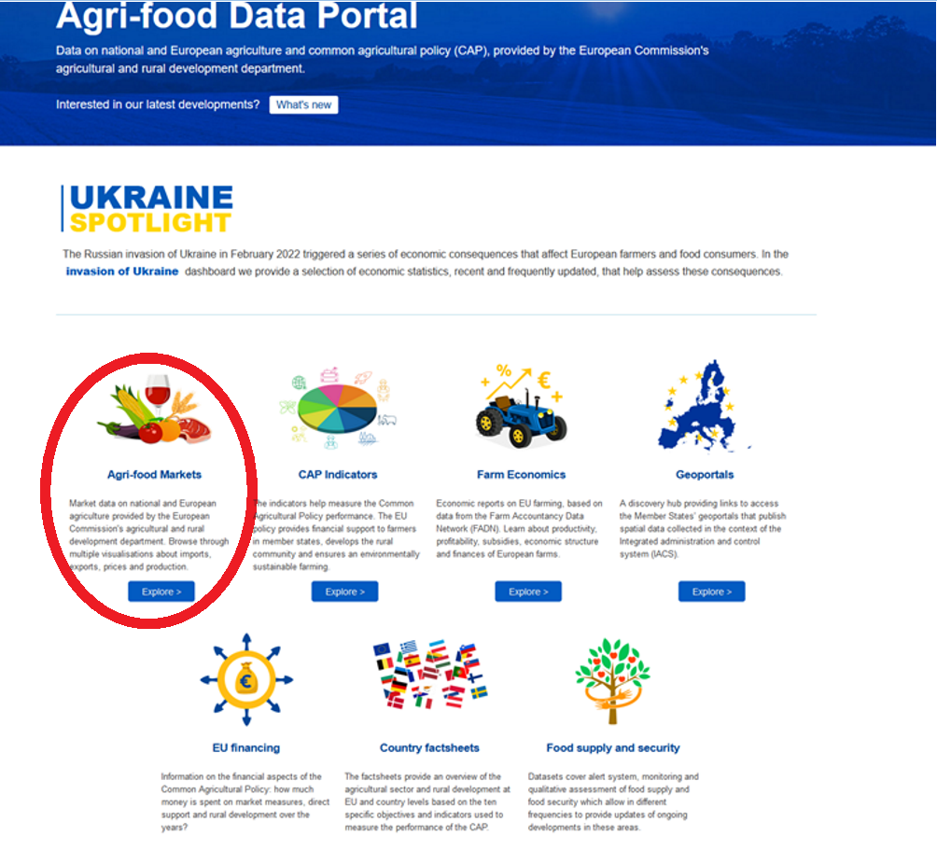

Click the menu “Agri-food Markets”, to redirect to it. (<https://agridata.ec.europa.eu/extensions/DataPortal/agricultural_markets.html>)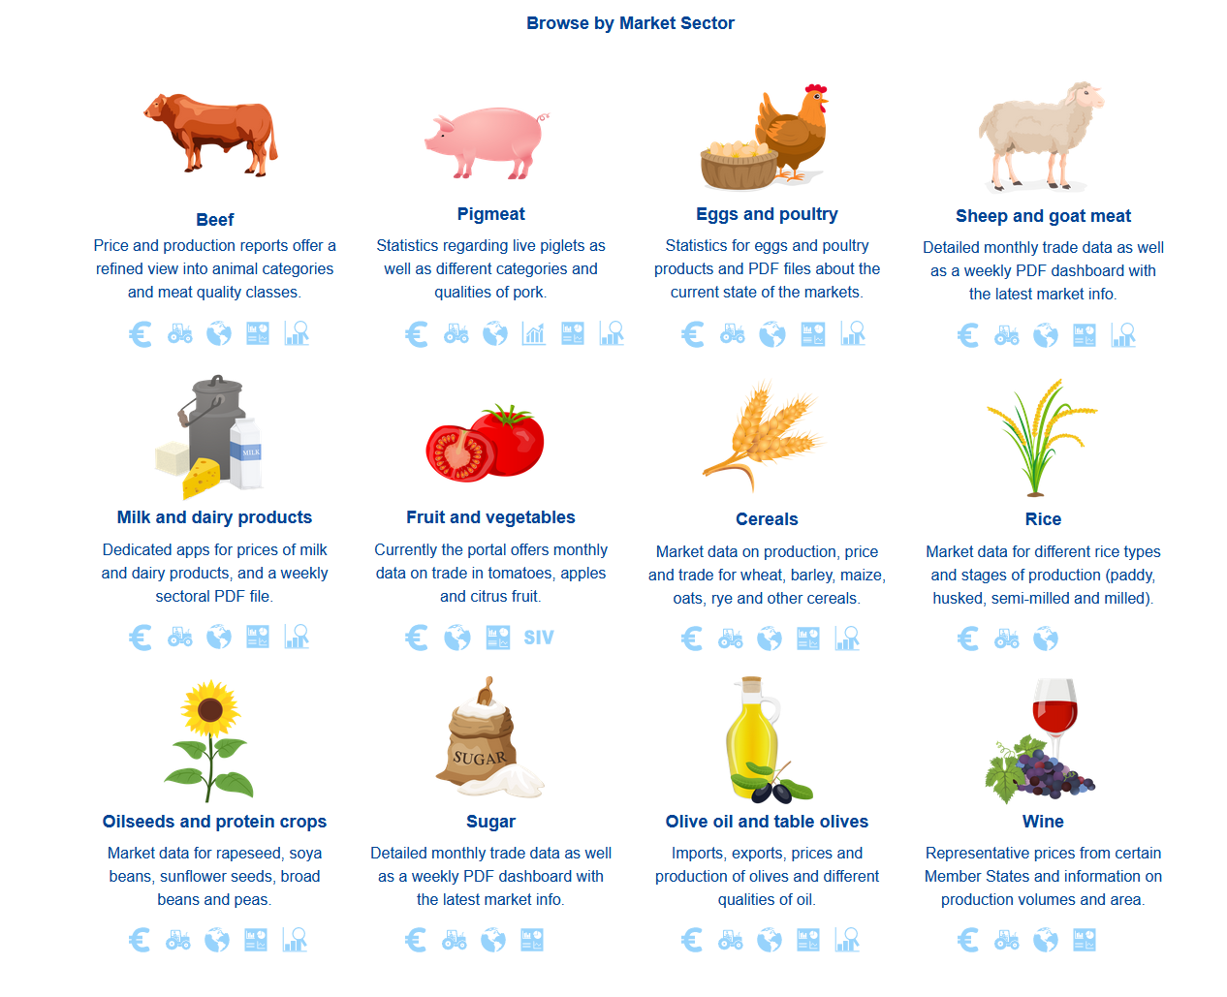

Dashboards can be selected based on various Market Sectors. Additionally, all the dashboards available can be viewed in: <https://agriculture.ec.europa.eu/data-and-analysis/markets/overviews/market-overview-sector_en>

**Market Sector Selection/Exclusion Rationale**

**Exclusion**:

Ukraine’s invasion has caused disturbances or even complete termination of trade majorly influencing the production of **Oilseeds and Protein Crops** (like Sunflower seeds, Rapeseed), **Cereals** (such as: Wheat, Barley, Corn) and **Olive oil and table olives** (like Sunflower oil). This drastically impacts the overall analysis especially in terms of Europe as well as Worldwide. Hopefully this situation is temporary and so making future predictions with the current situation in mind is counterproductive. Hence, I have excluded it from the analysis.

**Inclusion:**

Ireland’s niche market is **Beef**, **Pigmeat**, **Eggs and Poultry**, **Sheep and goat meat**, **Milk and dairy products**, **fruit and vegetables**.

Out of these, I have chosen to examine: **Cattle meat**, **Cranberries** and **Potatoes** and compare **Ireland** with **Netherland**, **Germany**, **France** and **Belgium**.

**Dashboard of Beef**

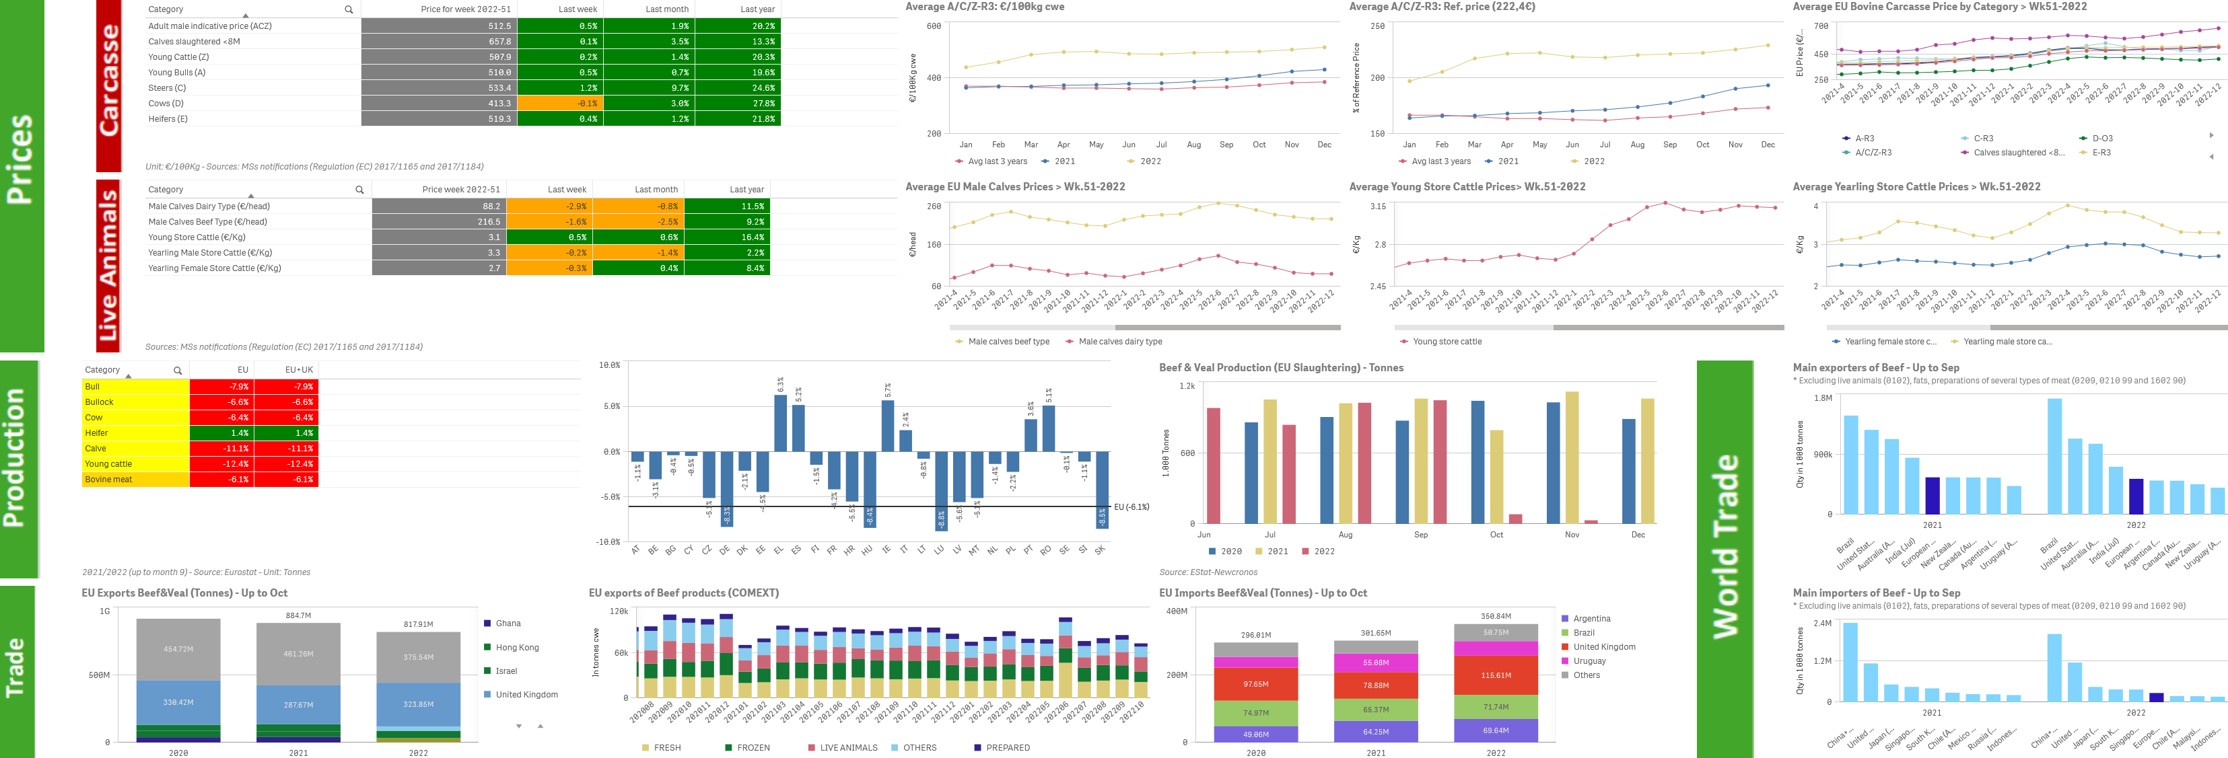

https://agridata.ec.europa.eu/extensions/DashboardBeef/Dashboard.html

**Dashboard of Pigmeat**



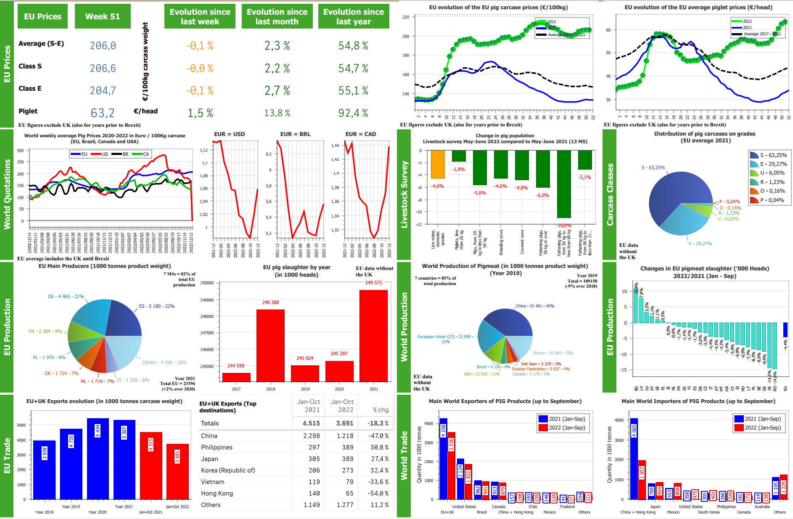

https://agridata.ec.europa.eu/Reports/Pigmeat_Dashboard.pdf

**Dashboard of Eggs and Poultry**

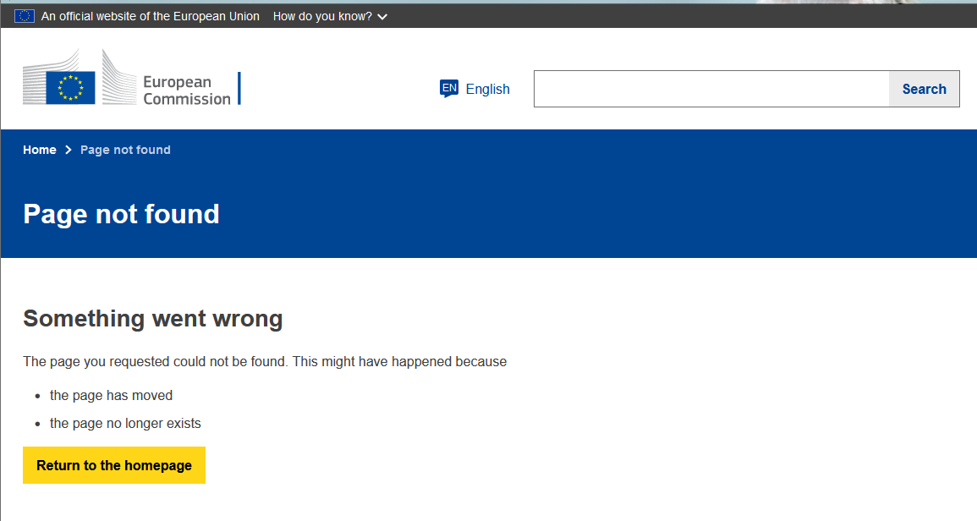

<https://commission.europa.eu/sites/default/files/food-farming-fisheries/farming/documents/eggs-dashboard_en.pdf>

<https://commission.europa.eu/sites/default/files/food-farming-fisheries/farming/documents/poultry-meat-dashboard_en.pdf>

**Dashboard of Sheep and goat meat**



https://ec.europa.eu/info/sites/info/files/food-farming-fisheries/farming/documents/sheep-meat-dashboard_en.pdf

**Dashboard of Milk and dairy products**

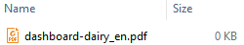

<https://ec.europa.eu/info/sites/info/files/food-farming-fisheries/farming/documents/dashboard-dairy_en.pdf>

**Dashboard of Fruit and vegetables**

Apples and Tomatoes



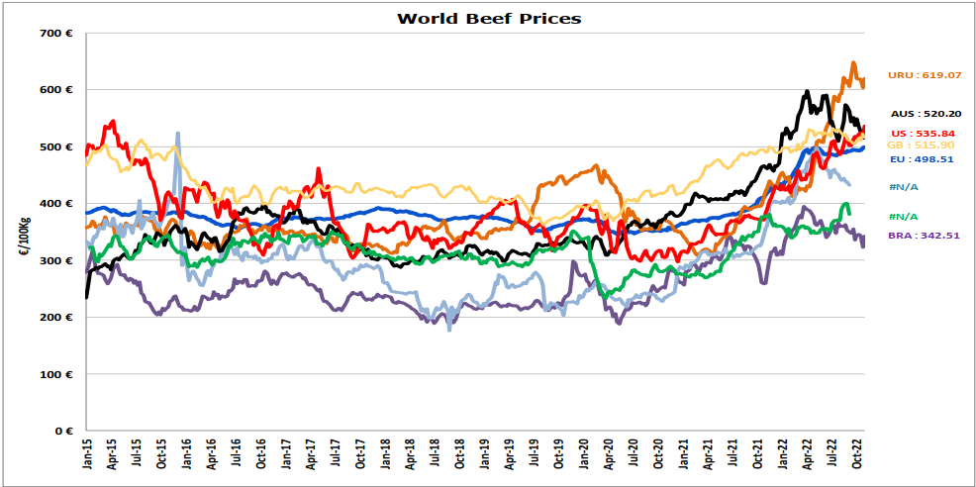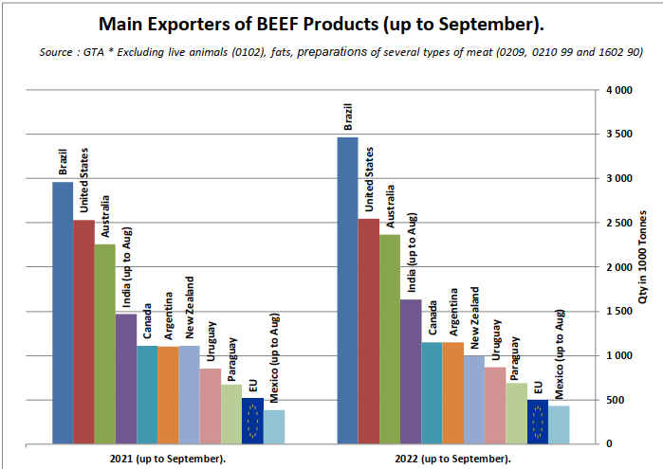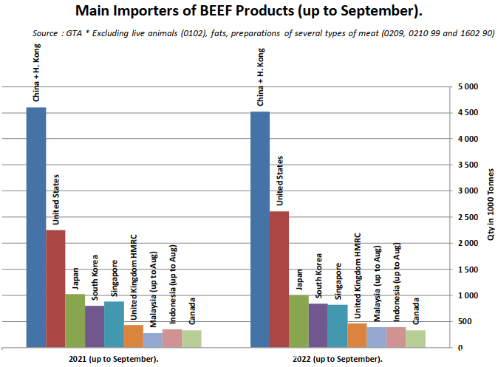

# Project Justification & project approach

Based on research the major trading partners of Ireland are EU members (especially Germany, France, Belgium, Netherlands). For this reason (as well as to further investigate EU’s CAP), I decided to use them for the analysis.

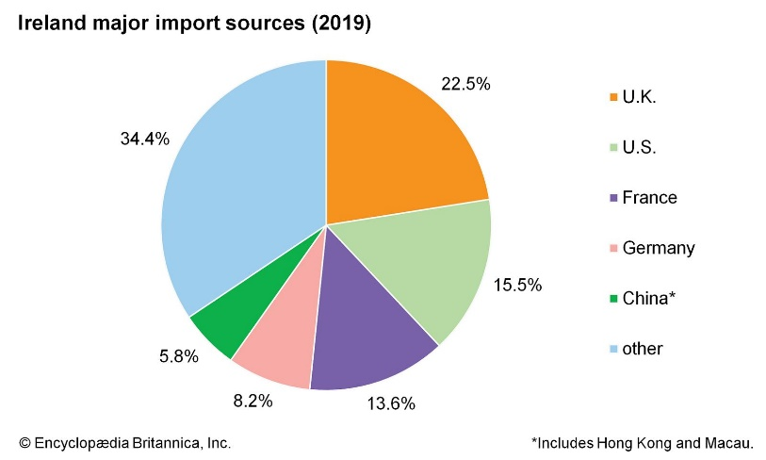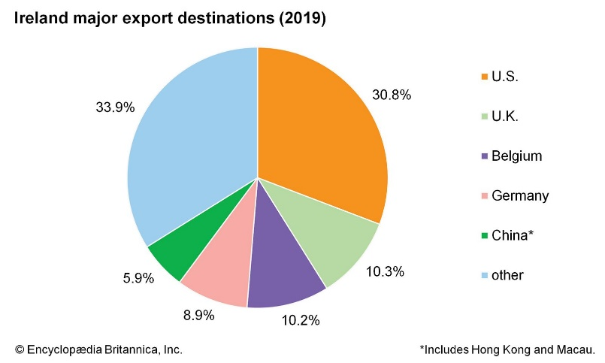

Source: [*https://www.britannica.com/place/Ireland/Trade*s](https://www.britannica.com/place/Ireland/Trades)

# 1. Business Understanding

## Area/Objectives of Research:

I have been tasked to **analyse Ireland**’sAgricultural data and comparing the Irish **Agri** **sector** **with other countries** worldwide. Analysing forecasting, sentiment analysis and evidence based recommendations for at least 2 areas of the sector as well as a complete rationale of the entire process used to discover my findings (such as trends and correlations…) from globally recognised official sources. As it is discussed in Data Gathering, I decided to research animal stock (such as **Beef**, **Pigmeat**, **Eggs and Poultry**, **Sheep and goat meat**, **fruit and vegetables** (Potatoes and Cranberries) in the agricultural sector. This should assist decision making for Irish farmers.

# Data Collection

For the analysis I collected data from a number of sources including the publically available data from UN’s FAOSTAT, YouTube’s Comments database. The data was centrally focused on the supporting farmers with effective real time decision-support. These Data are listed below:

## FAOSTAT



*https://www.fao.org/faostat/en/#data*

It was used for its detailed global trading data.

### Source:

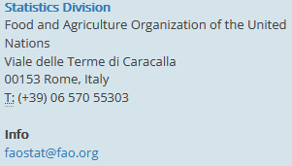

Used the Trade_DetailedTradeMatrix_E_All_Data_(Normalized) zip file containing:

* **All Data**: Trade_DetailedTradeMatrix_E_All_Data_(Normalized)
* **Flags**: Trade_DetailedTradeMatrix_E_Flags

## ISO

It was used for its standardized codes that made it possible to create maps.

### Source:

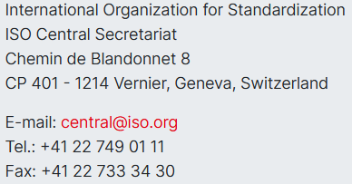

## YouTube API

It was used for the sentiment analysis.

### Licencing:

Can be found in the Appendix section.

# Datasets

### _TradeAnalysis

It contains global trading data.

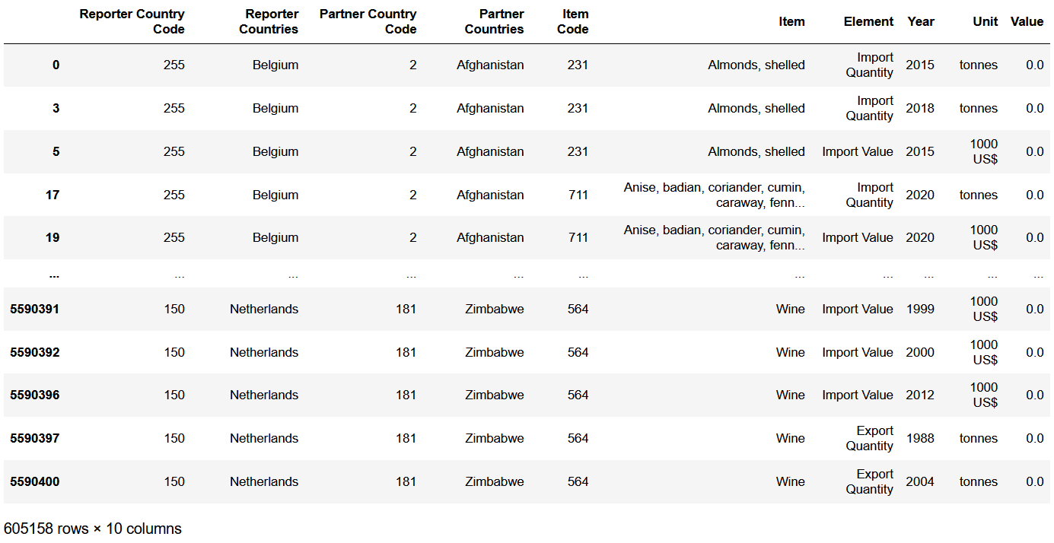

After Cleaning called (_TradeClean):

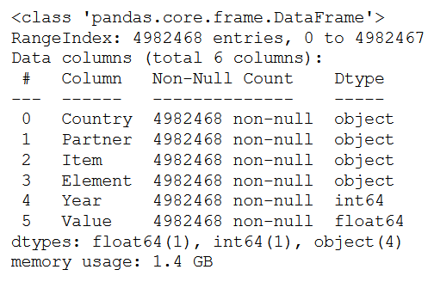

### _ISO-3166

Contains the national standards from the ISO official website (<https://www.iso.org/home.html>).

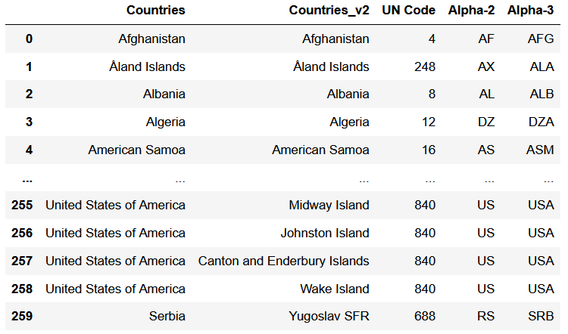

### _PriceAnalysis

From the FAOSTAT Database gathered from their website (<https://www.fao.org/faostat/en/#home>) and initialised for the analysis in the 0.Big Data Extraction notebook

### _Youtube_Comments

I used YouTube API to collect comments that I used to gain the sentiment people have towards cranberry processing and their sentiment of it as food.

More specifically the link was from:

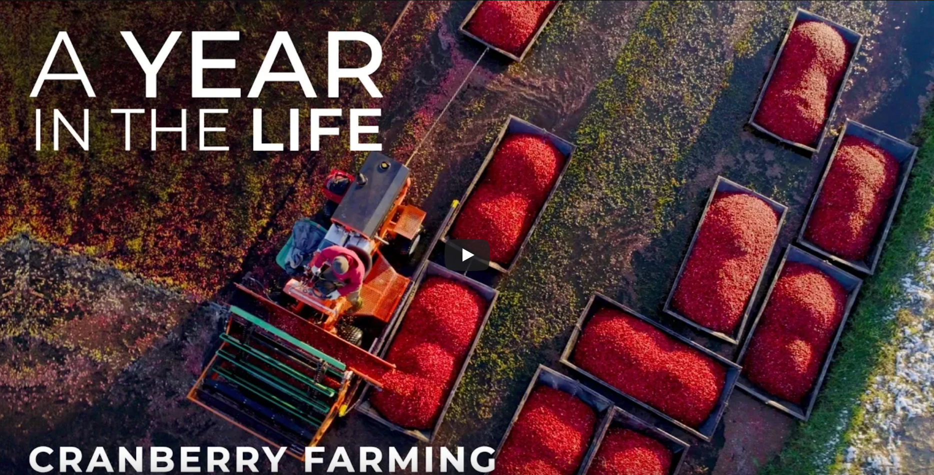



<https://www.youtube.com/watch?v=pGWP86dZ-_0>

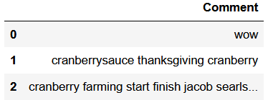

After preparation and cleanings

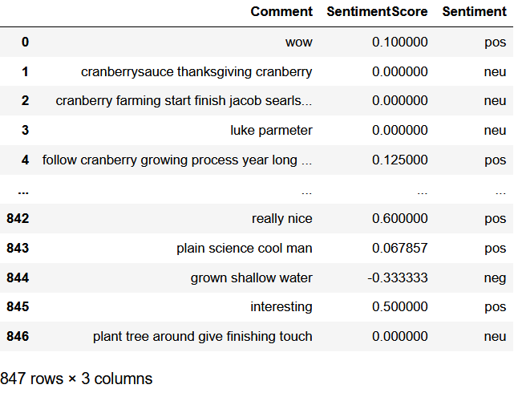

**Benefits**:

YouTube API has a lot of comments that people leave on a lot of videos relating to the topic.

**Challenges**:

There are scammers, trolls, people talking about unrelated topics, or about their feelings towards the YouTuber.

These need to be filtered from the data which is time consuming. People are also prone to sarcasm which is not picked up.

Data Understanding

**Cranberry Analysis**

* What is it people like/dislike about it?
* What recommendation can be given to Irish farmers to increase their supply?

**Trade (Import, Export) Analysis**

Applying Data Visualisation to plot:

* Ireland and/or its trade partner countries annual value
* Ireland’s product trade annual value

**Trade Balance Analysis**

* Positive and Negative influences
* Greatest impact
* Possible optimization for Ireland

# Data Preparation

## 0. Big Data Extraction

Since I had to handle big data, I did the usual process to reduce the drain on memory. I first only imported the necessary library pandas to manage the dataset. Analysed the memory usage and looked at the structure.

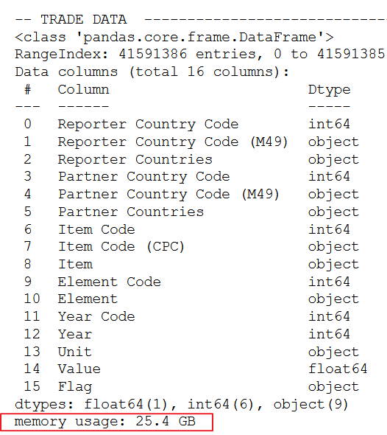

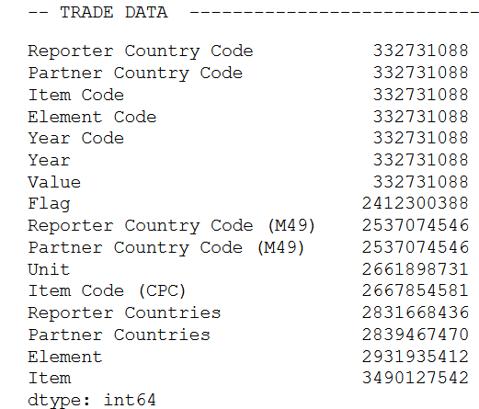

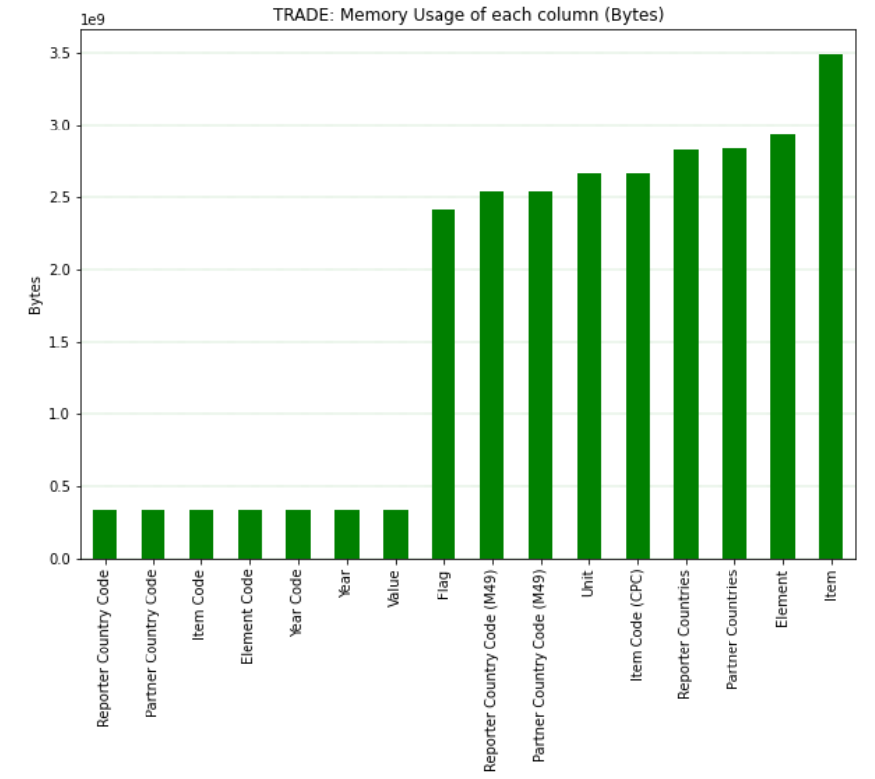

With this initial check I was able to remove any irrelevant data (for the analysis) from the datasets.

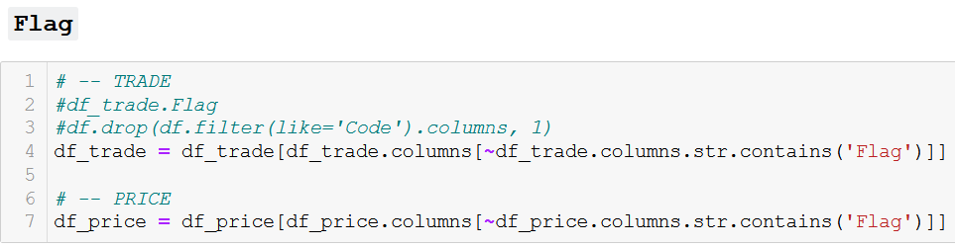

Also Duplicates.

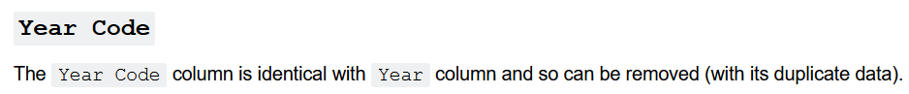







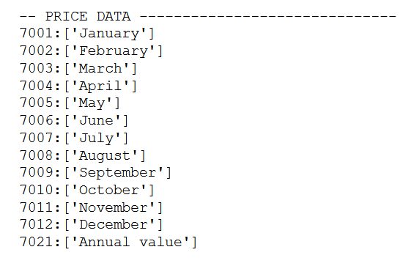



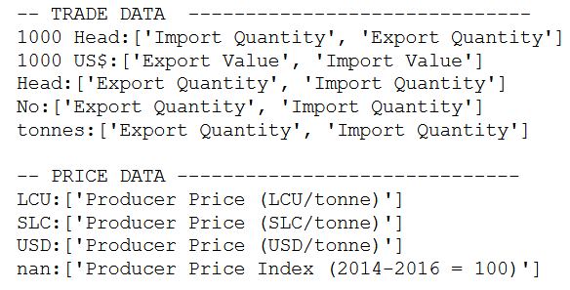

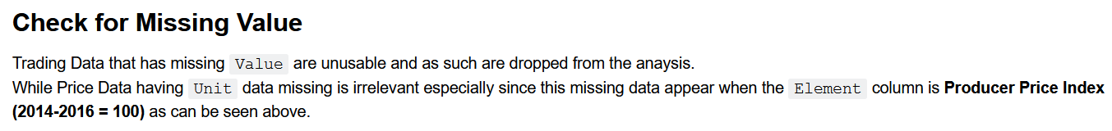

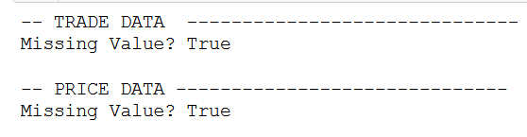

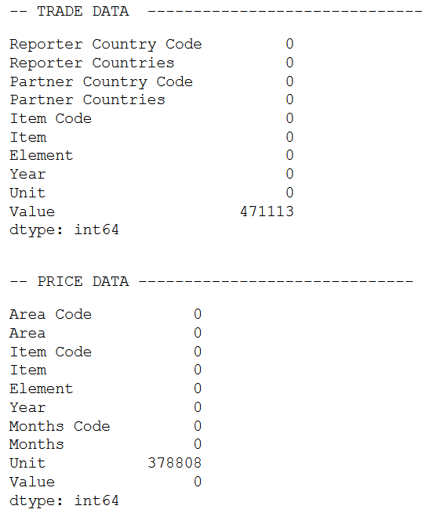

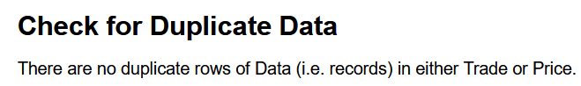

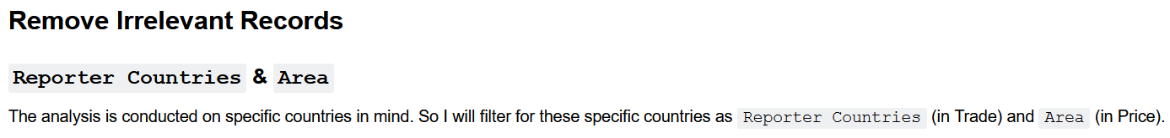

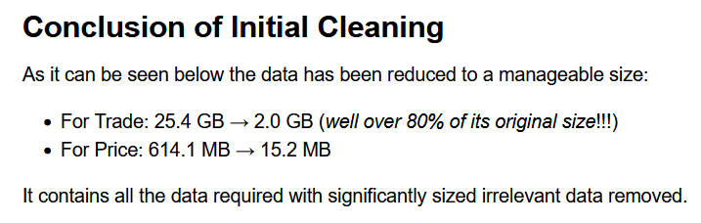

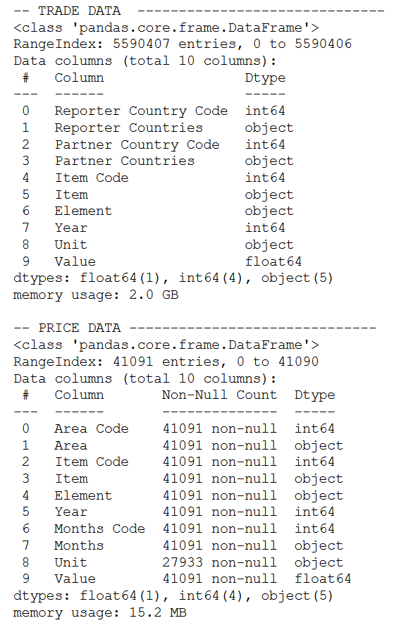

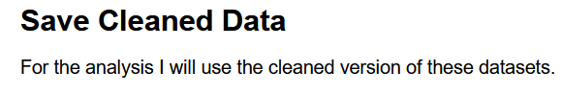

## _TradeAnalysis

This was the product of the Big Data Extraction notebook but still I did a couple of processing to the data.

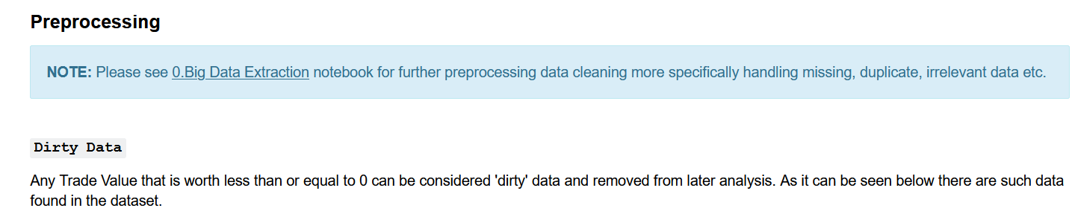

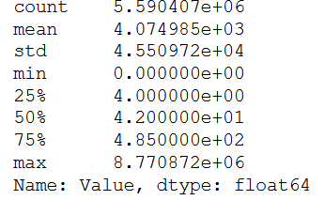

After removing:

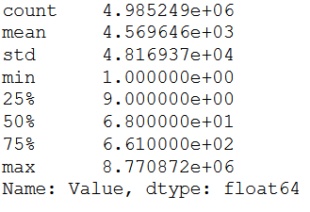

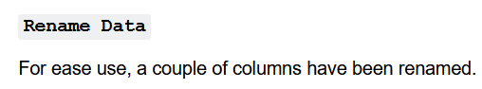

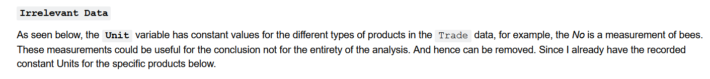

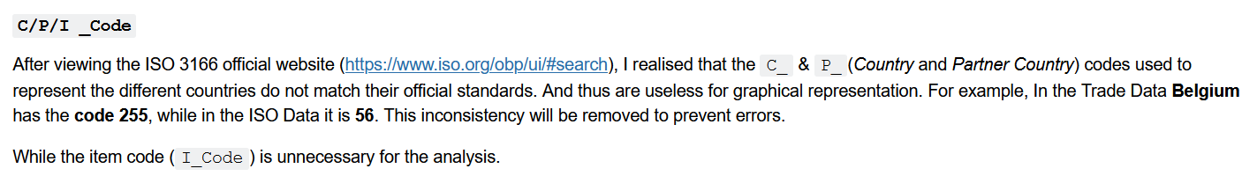



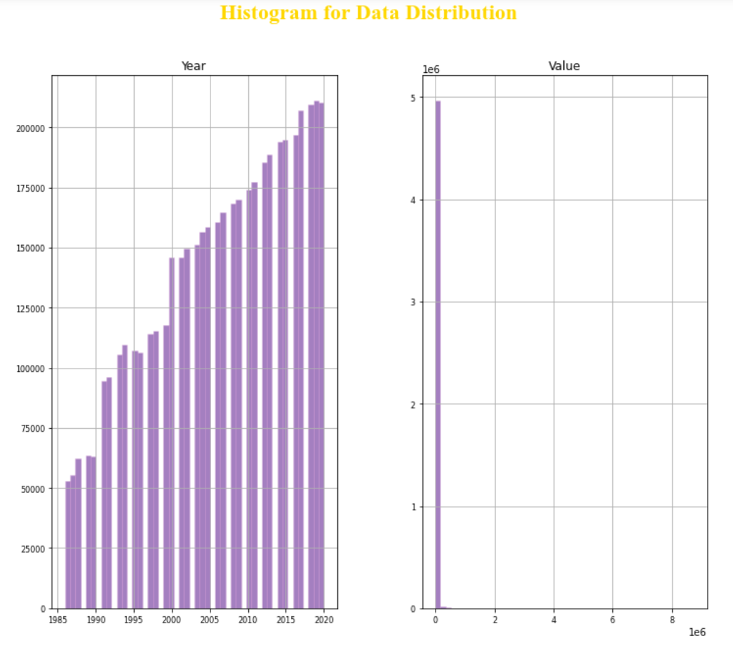

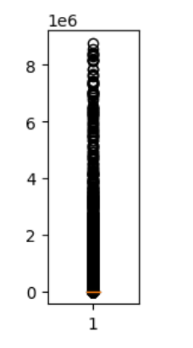



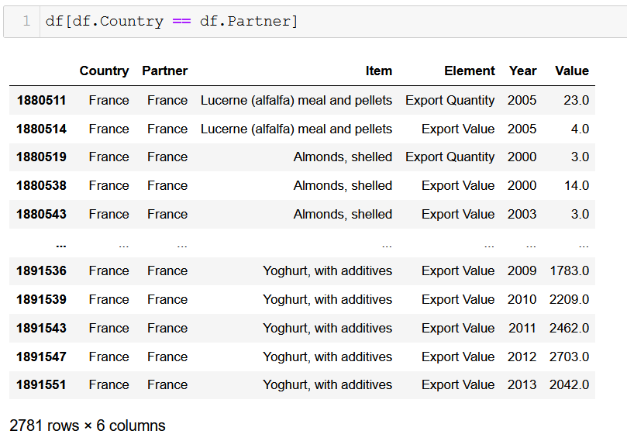

With this I was successful in removing unnecessary data.

Feature Engineering (Selection)

I added the ISO files 3 digit code to the Trade data to be able to map the global trade of Ireland to other countries.

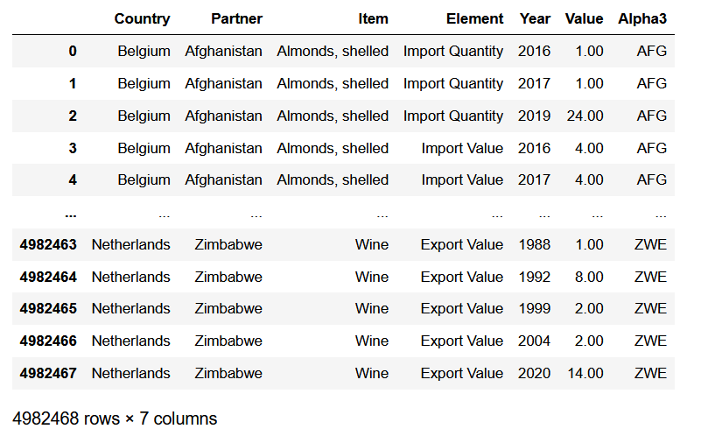

# Analysis

I did a couple types of analysis to research the topic.

## Global Trade

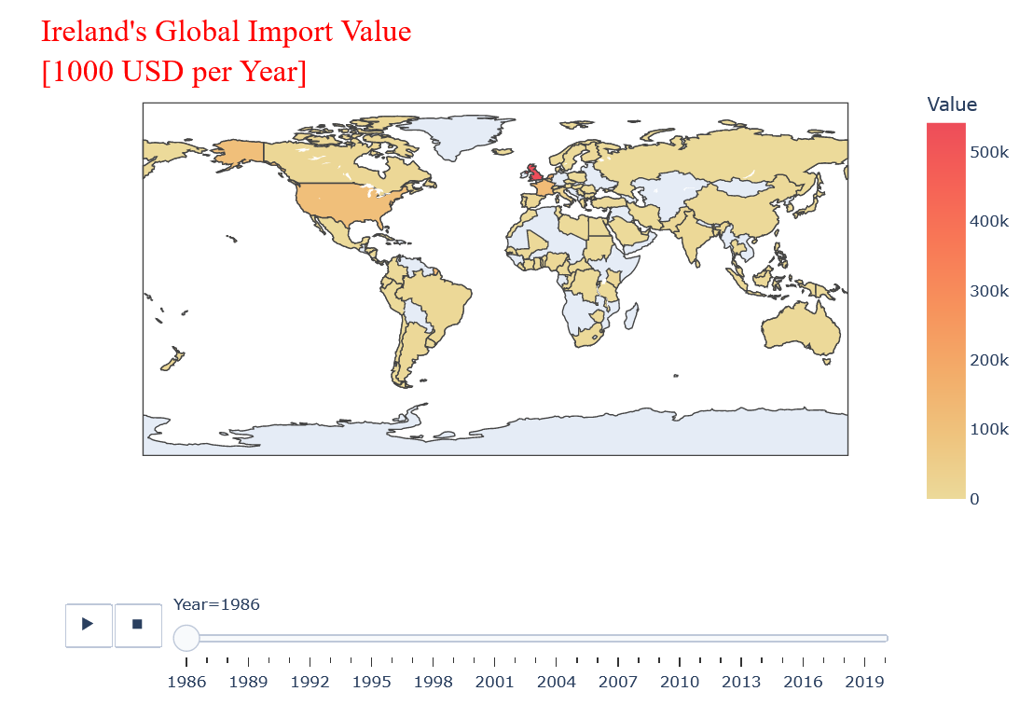

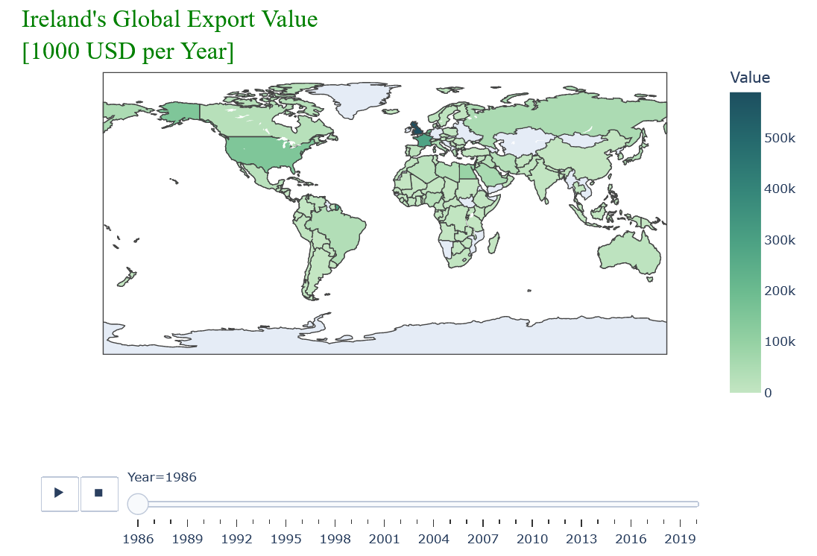

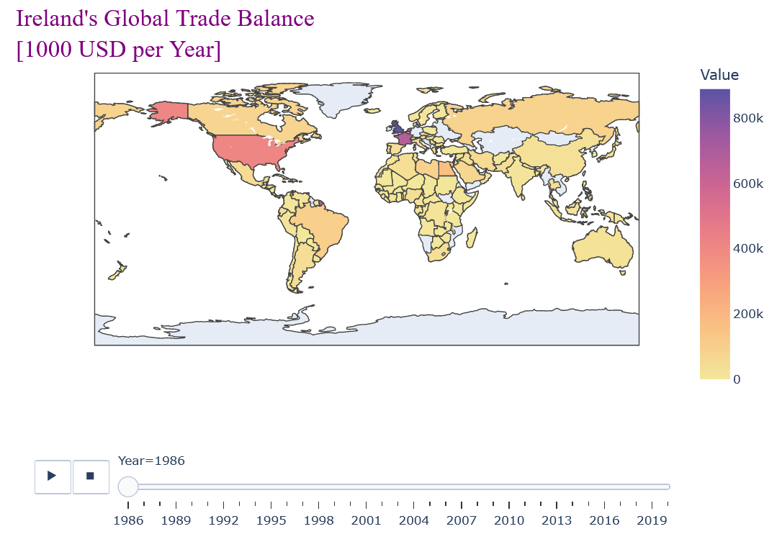

Ireland’s trade trend seems to be increasing.

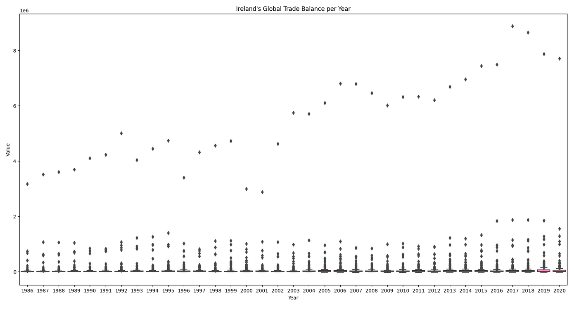

As can be seen from the forecast made on Ireland’s Export value.

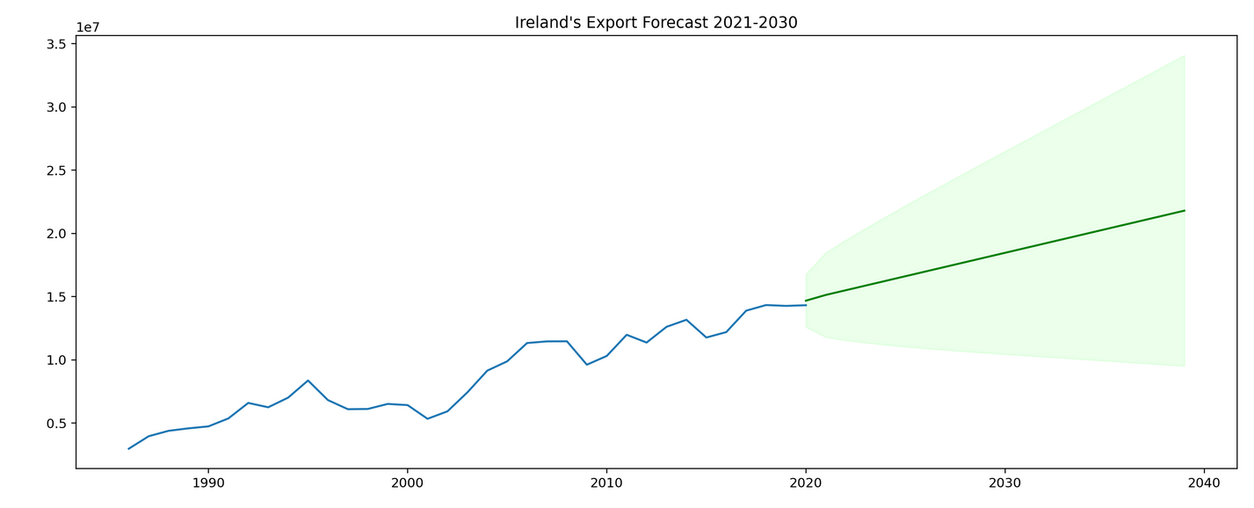

It is not something all EU countries seem to have in common as shown in Frances case:s

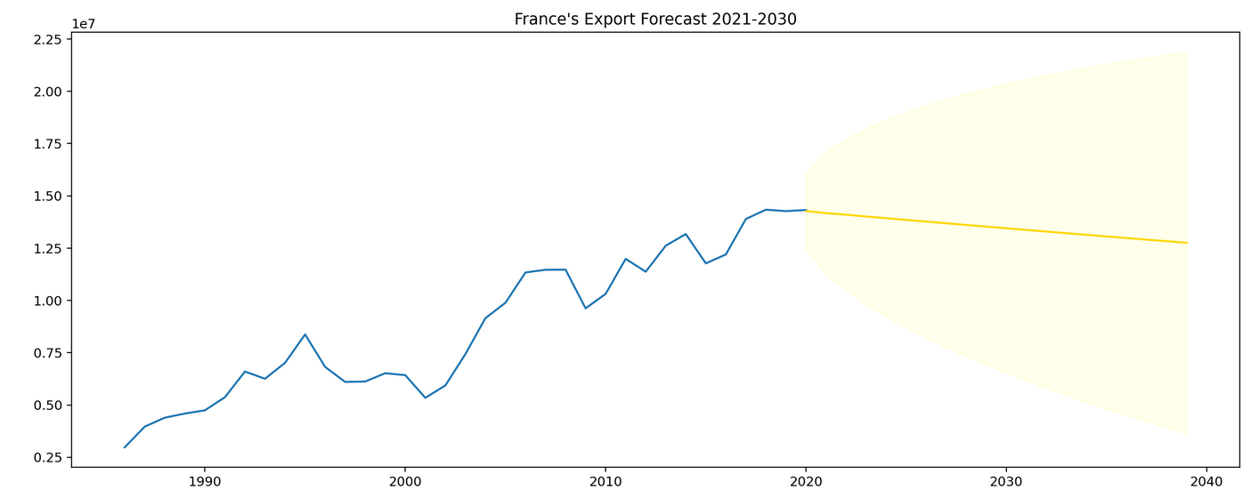

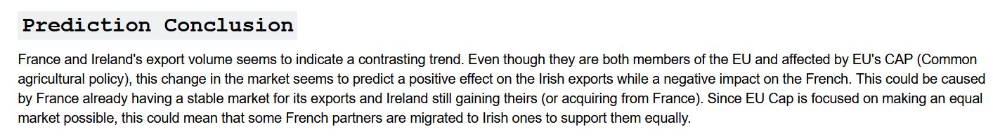

## Ireland’s Top trading Partners



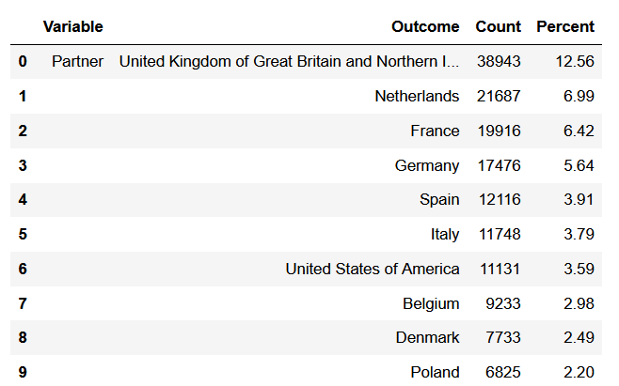

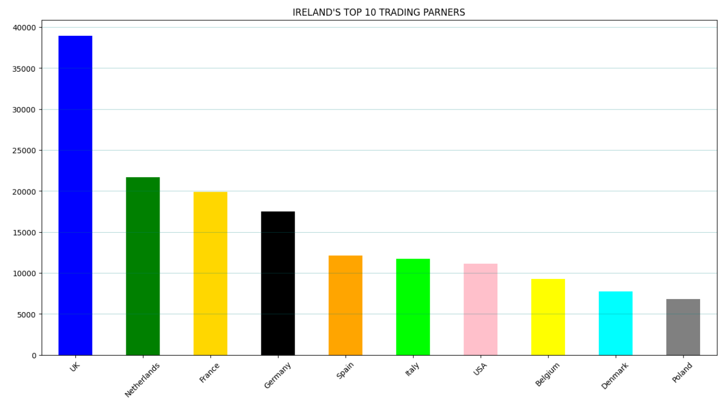

## Inferential Statistics on Annual Potato Production



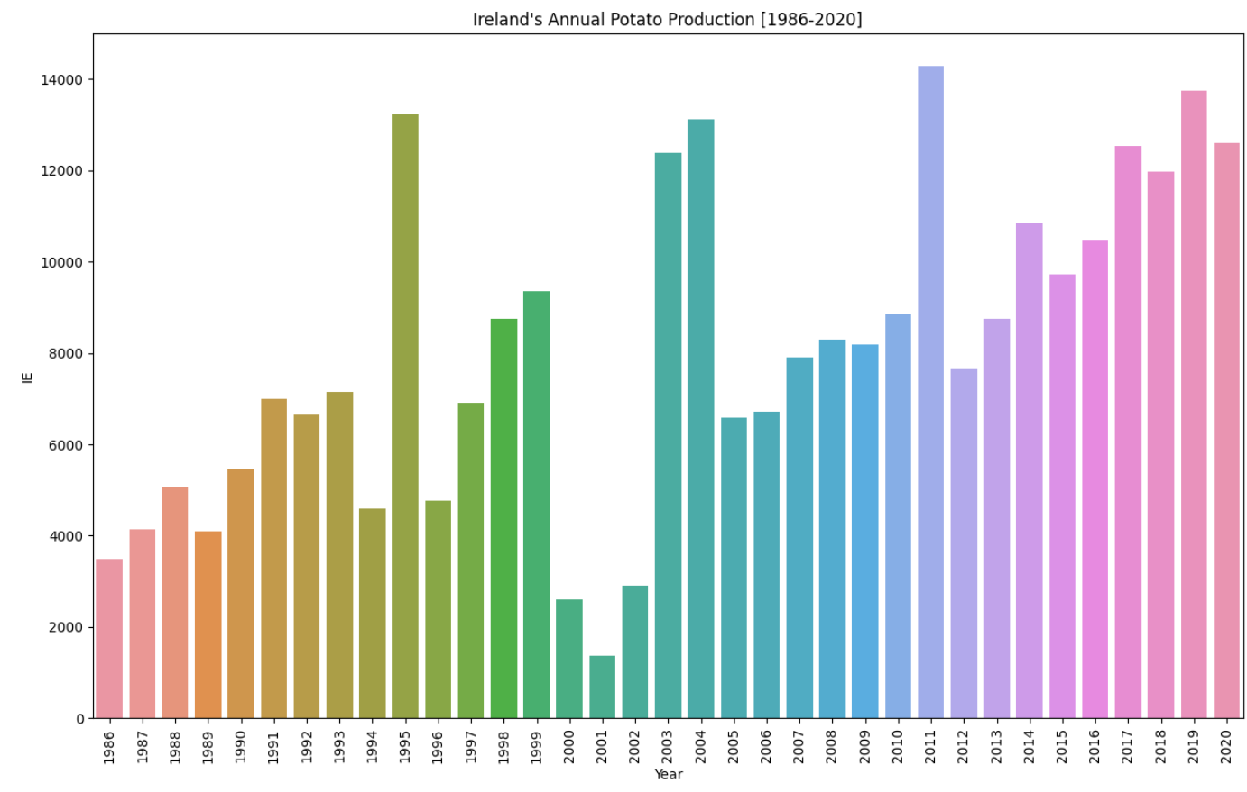

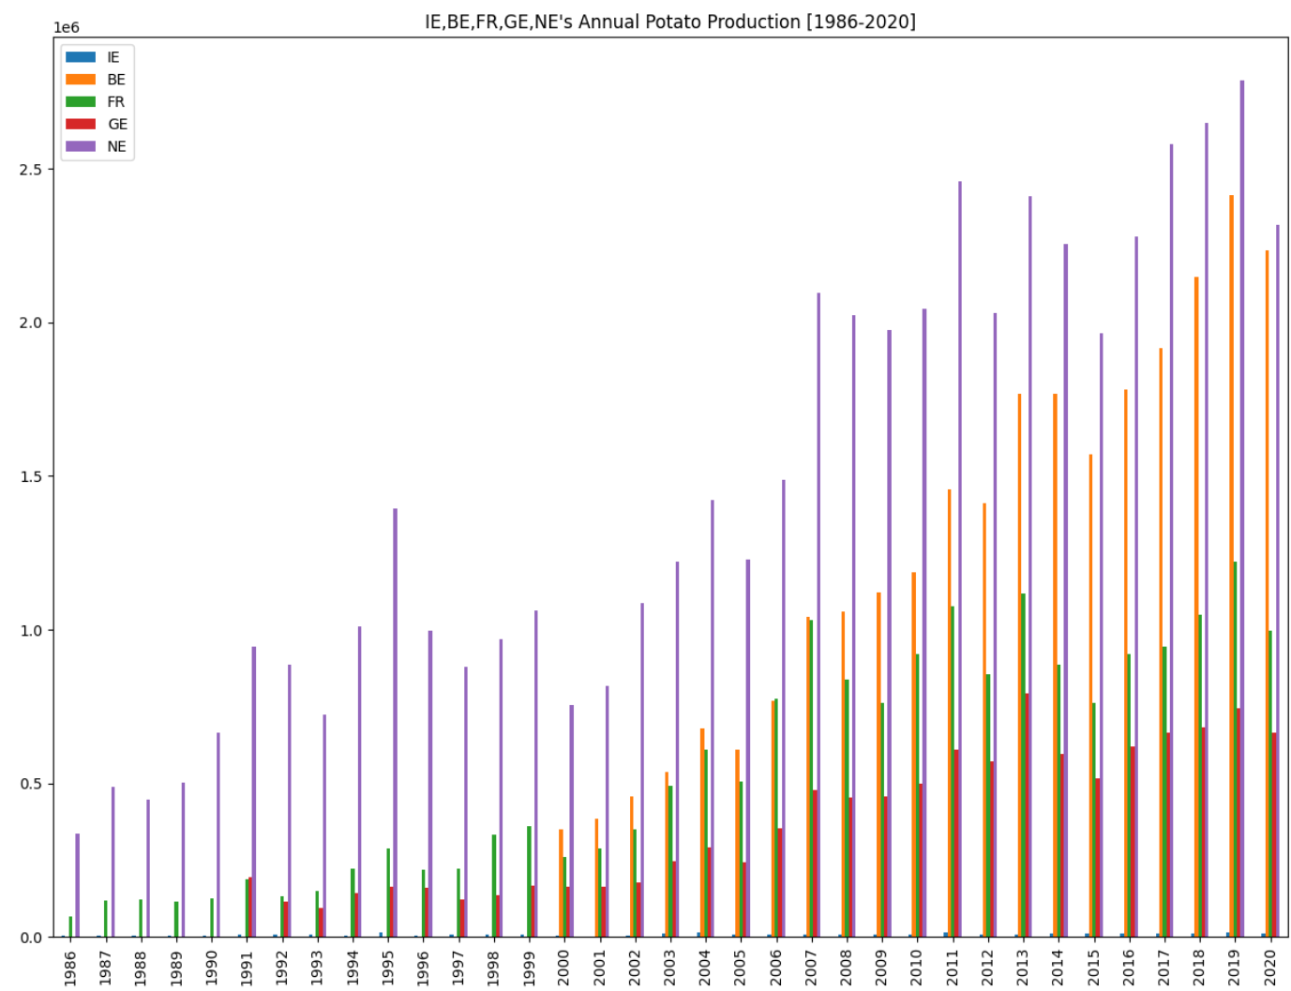

I then compared Ireland to the closest trending country to it in the above graph, i.e. Germany.

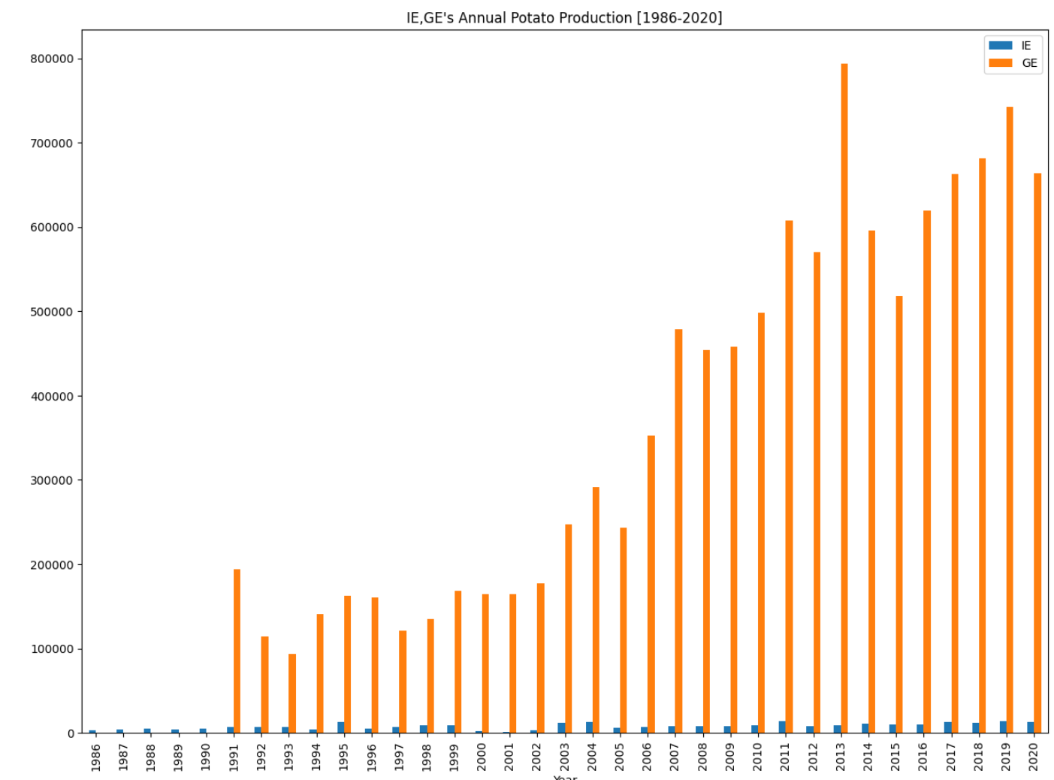

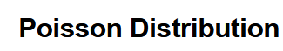

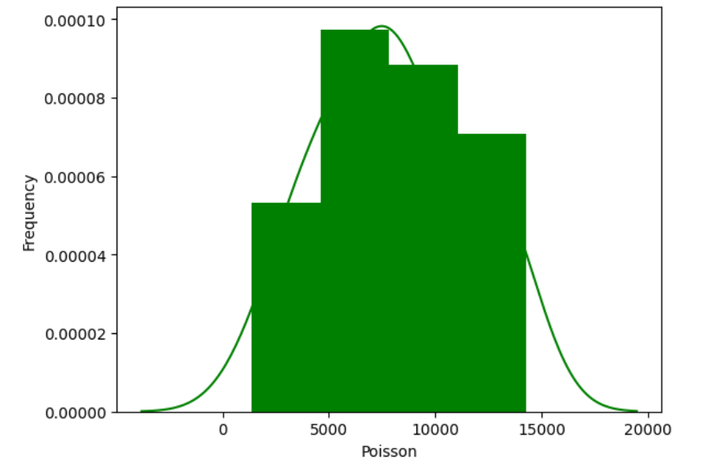

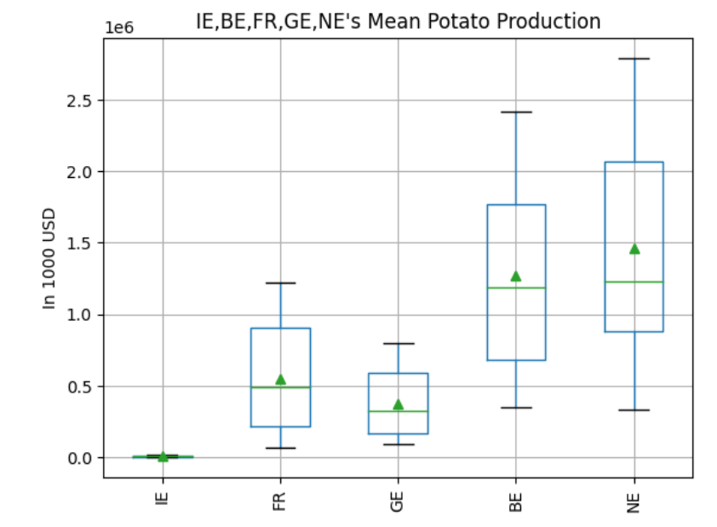

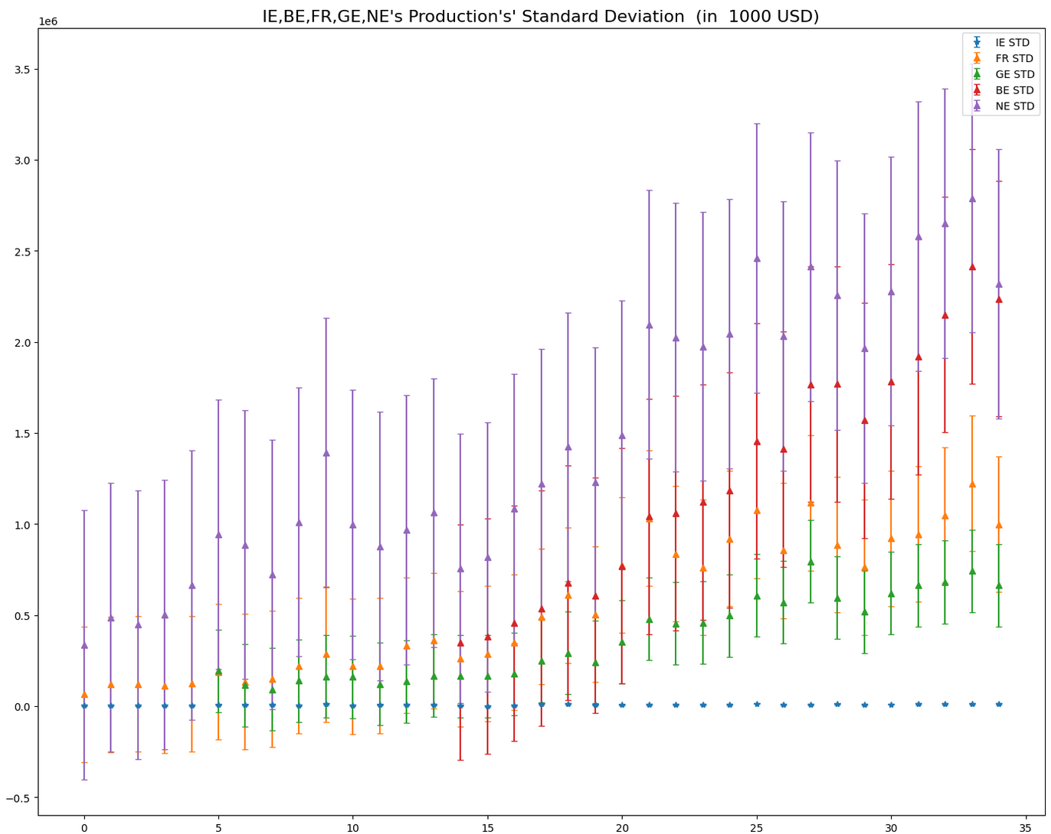

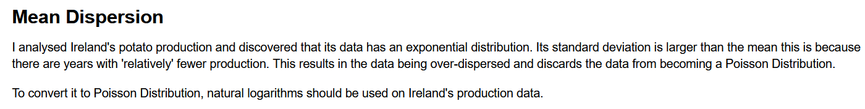

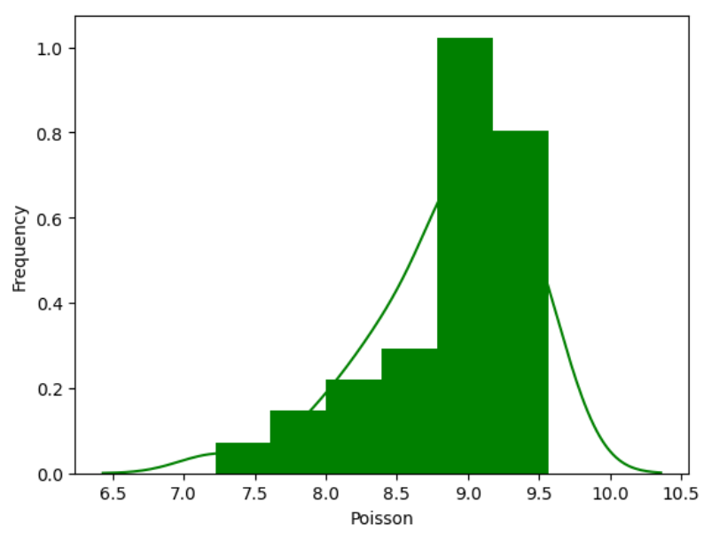

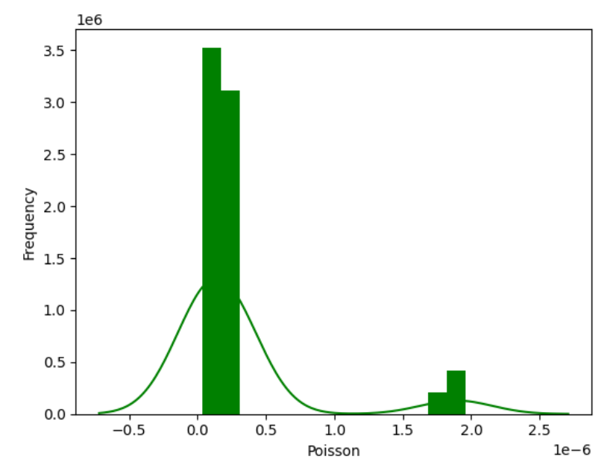

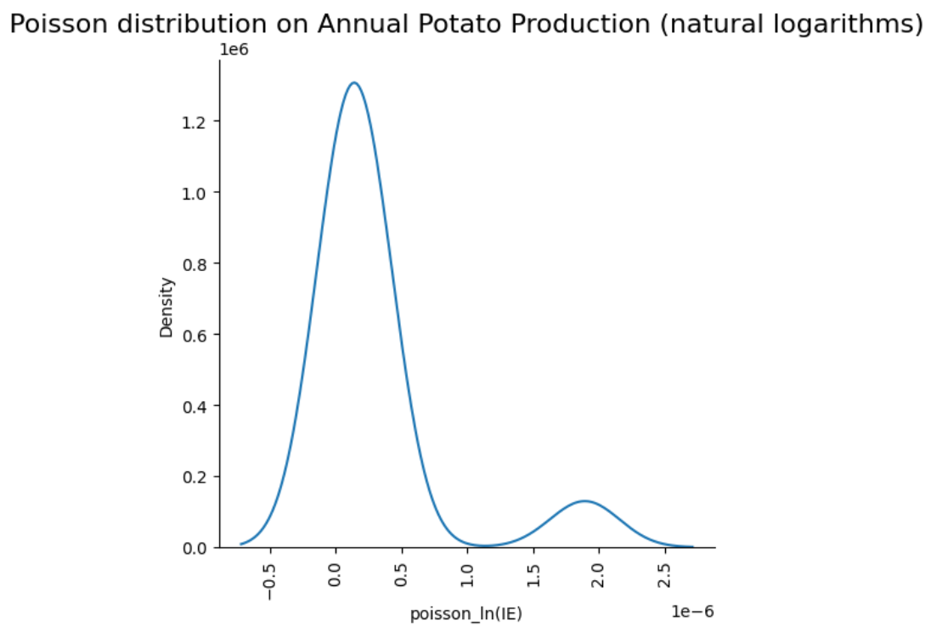

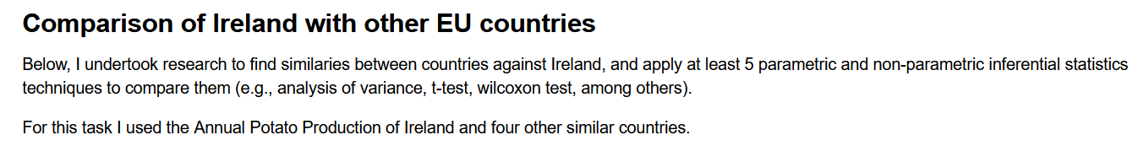

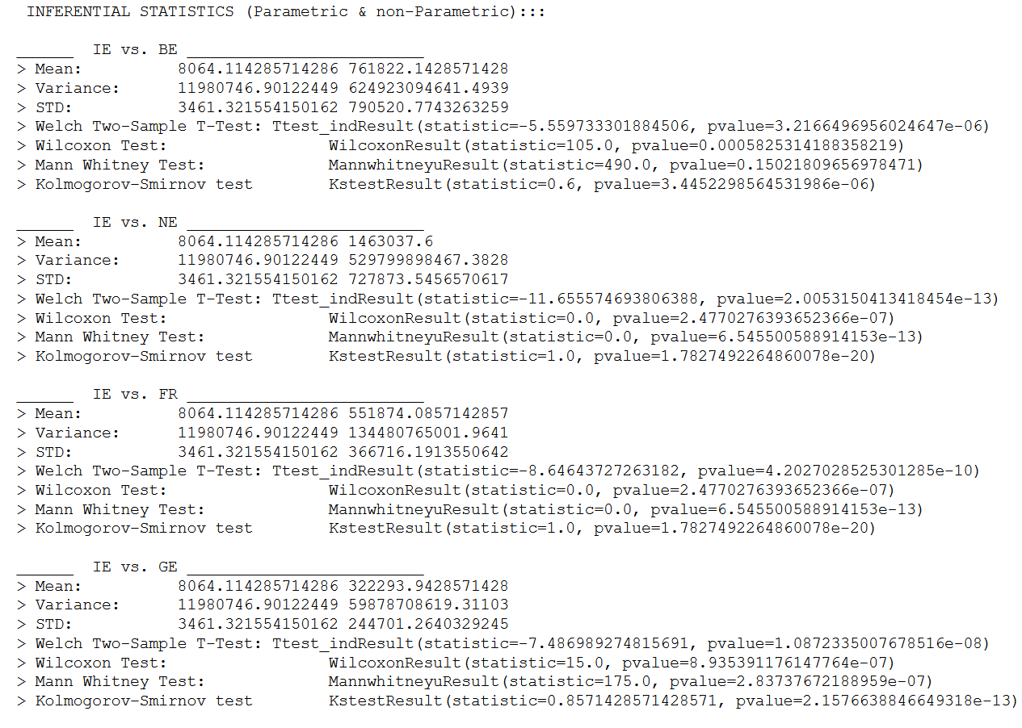

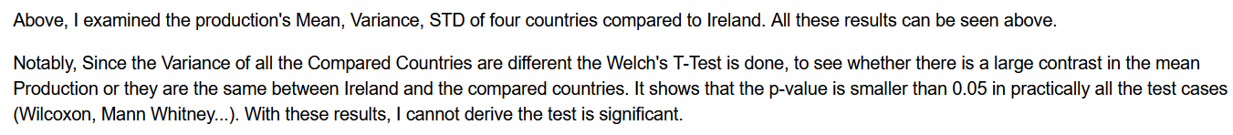

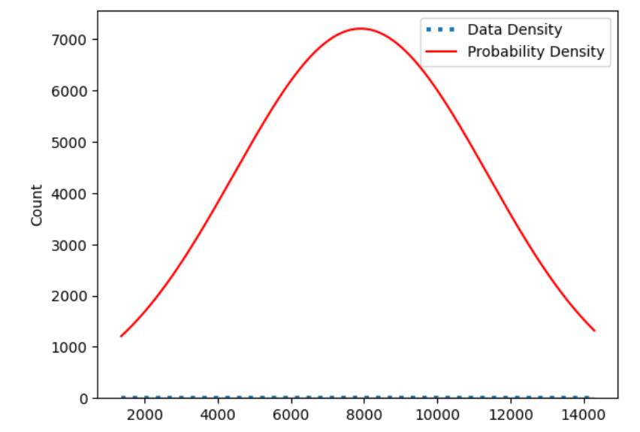

## Sentiment Analysis on Cranberries

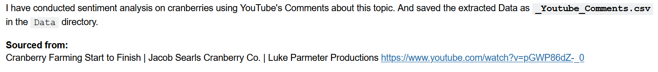

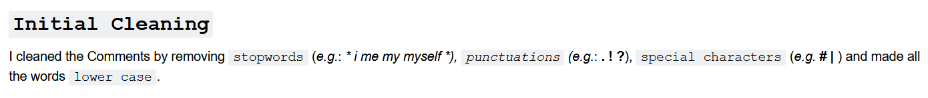



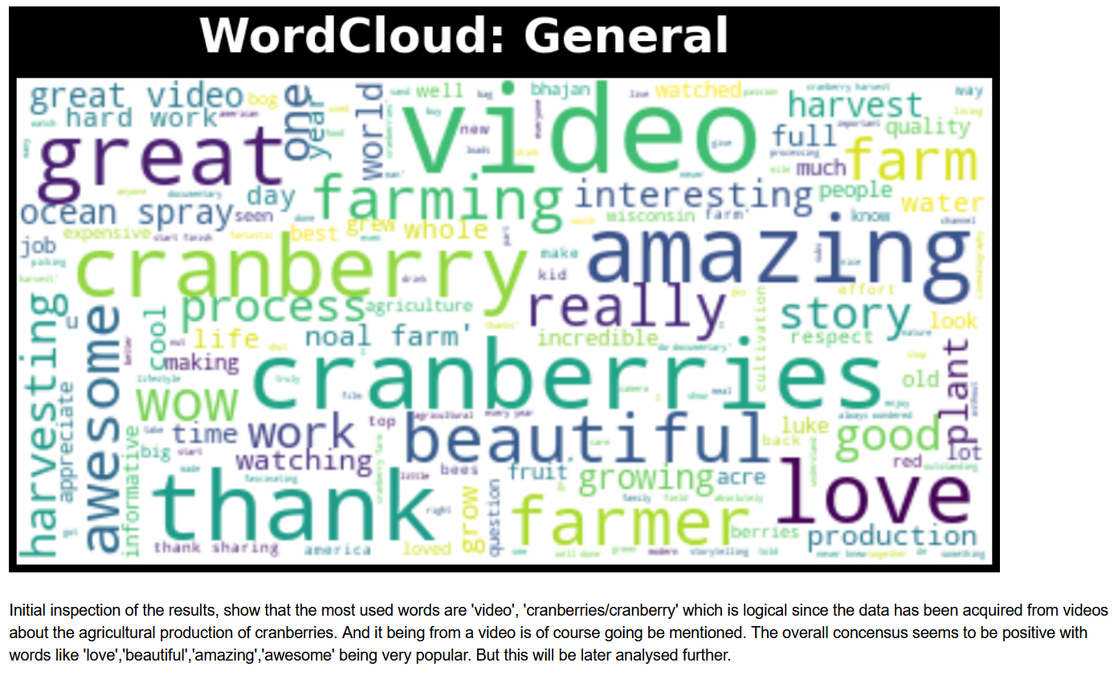

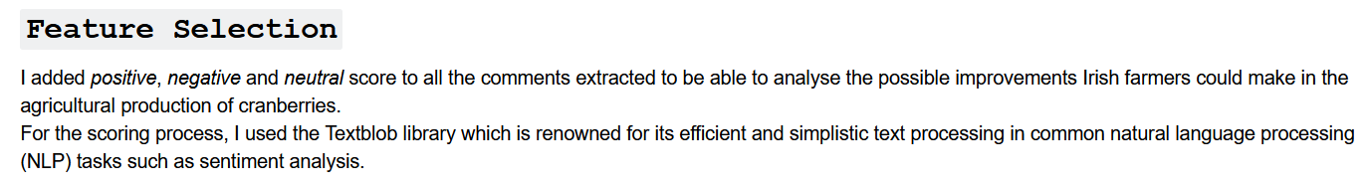

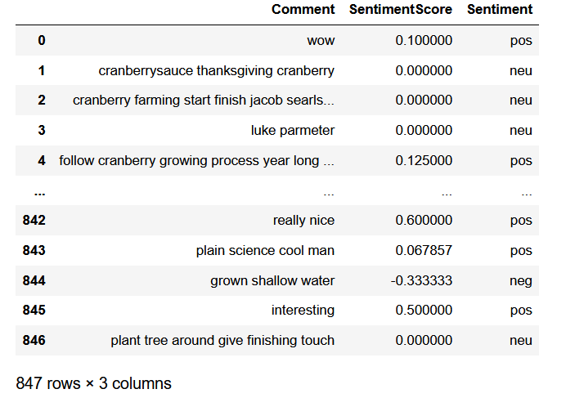

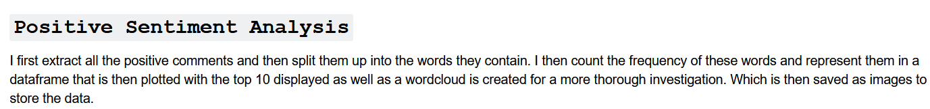

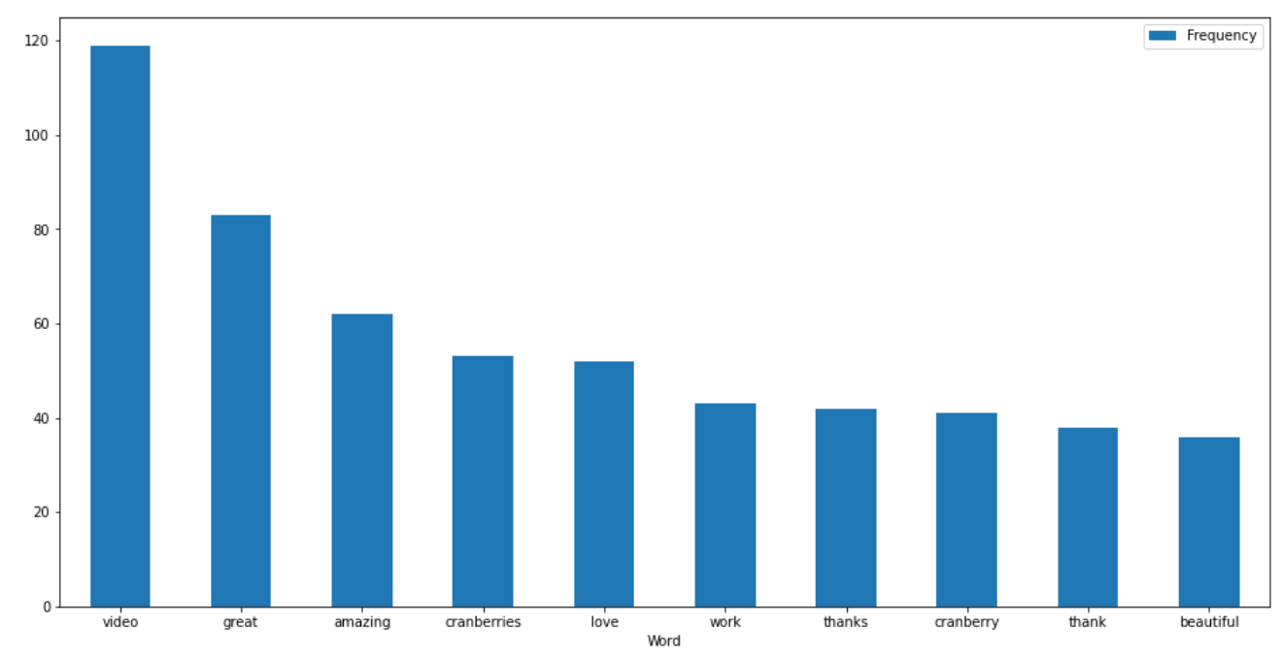

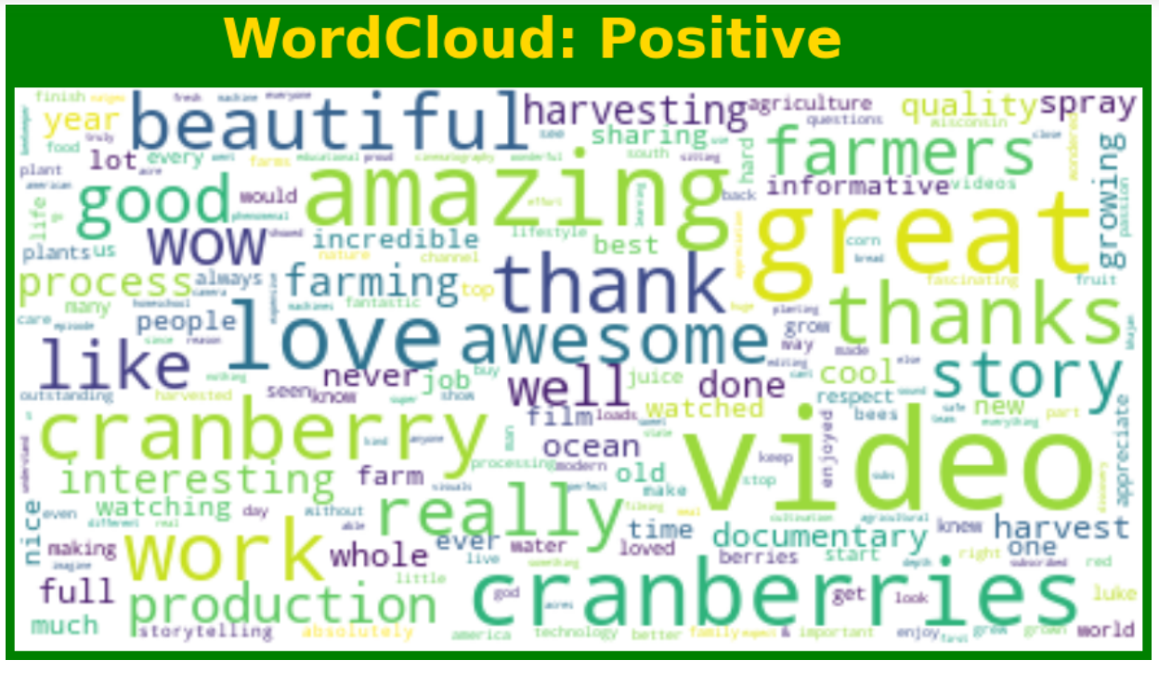

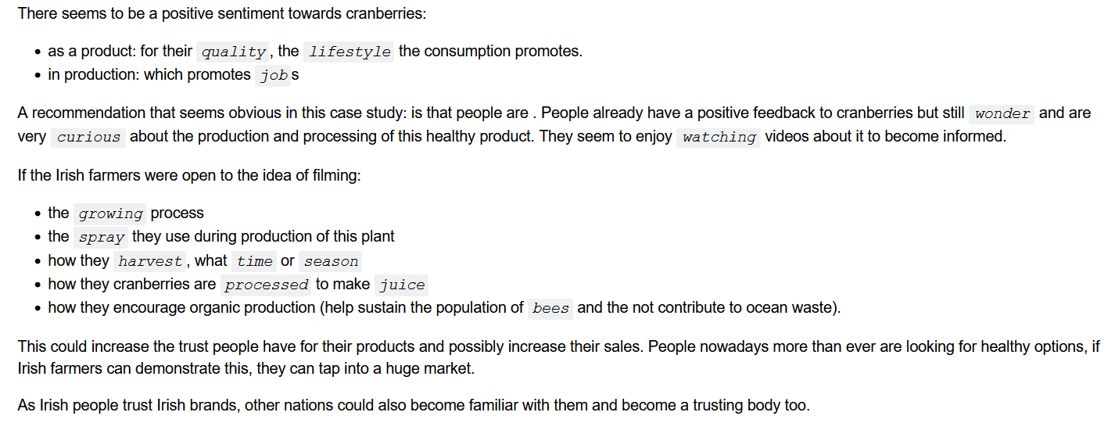

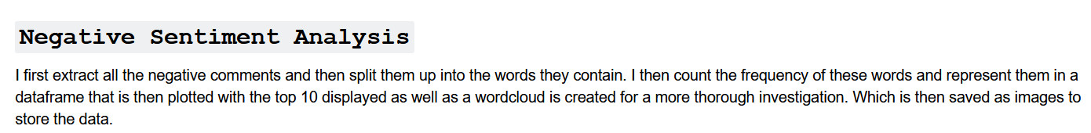

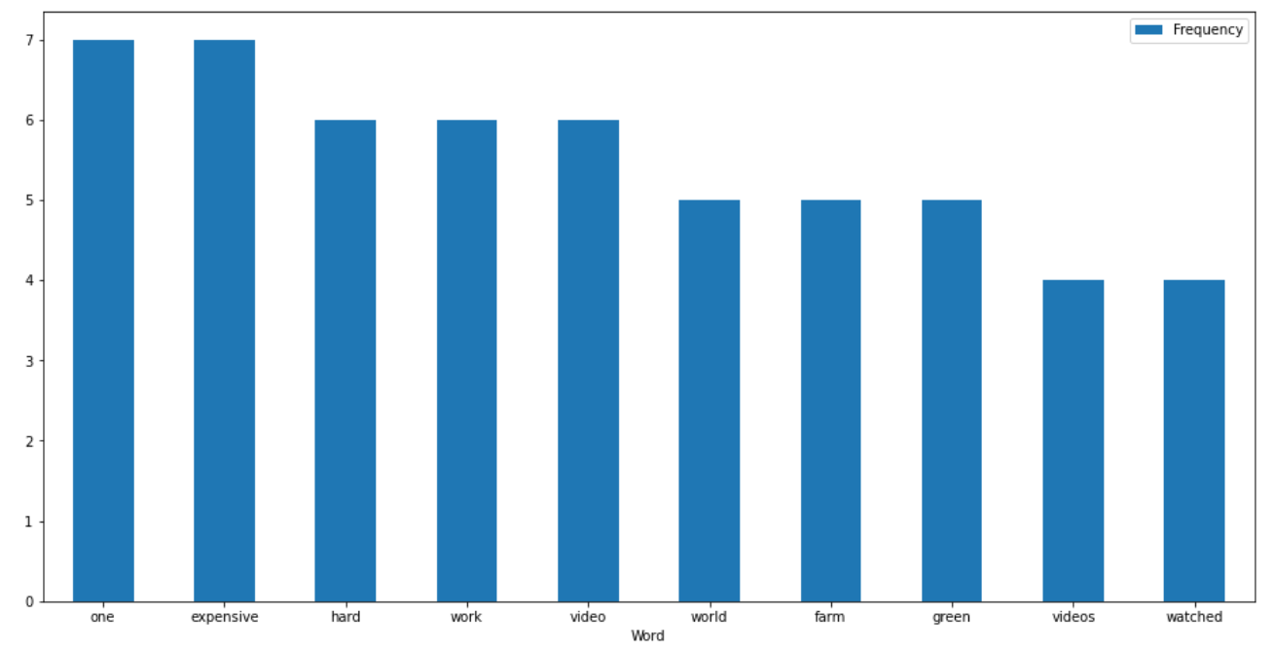

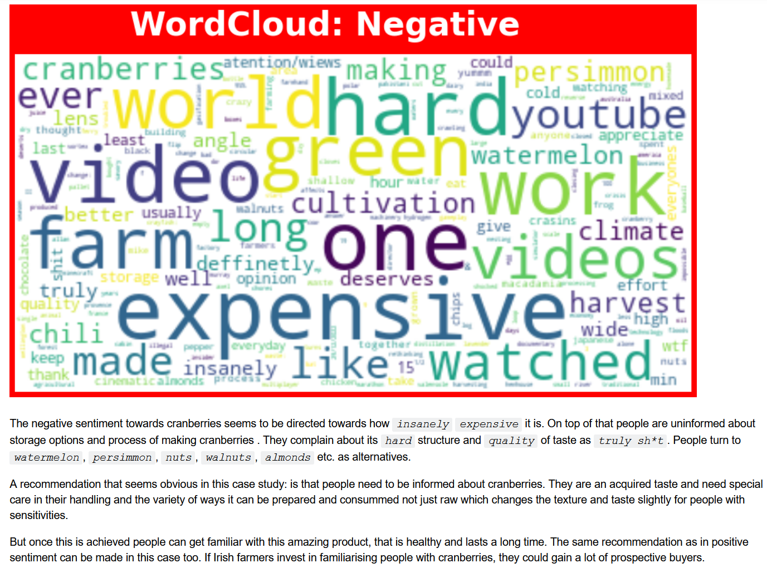

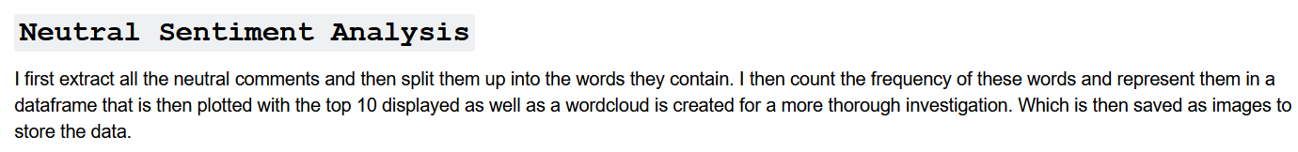

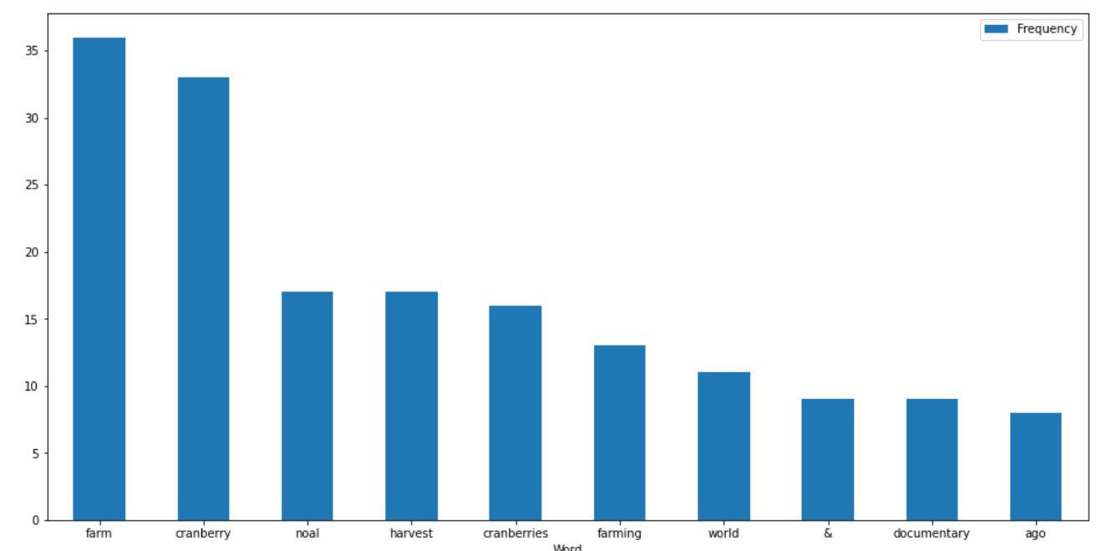

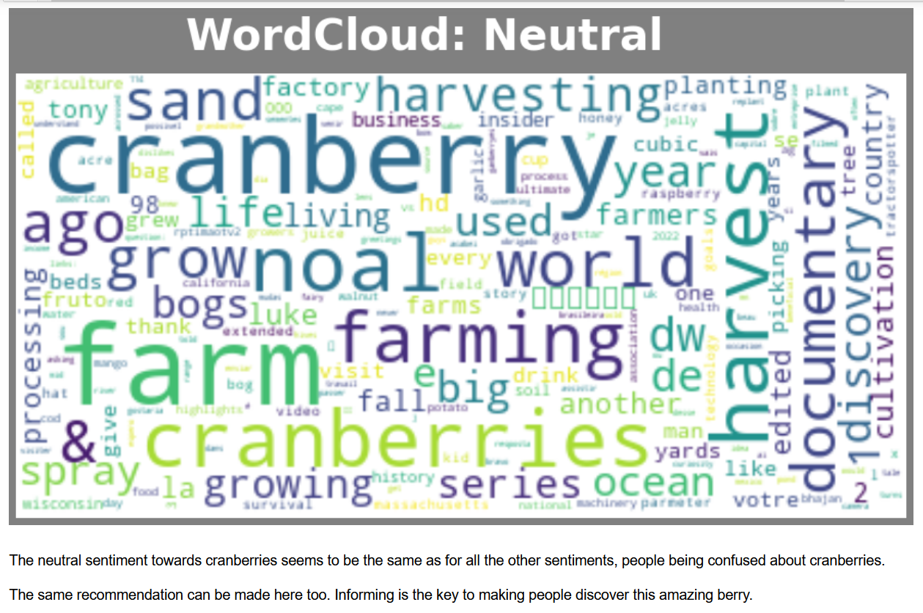

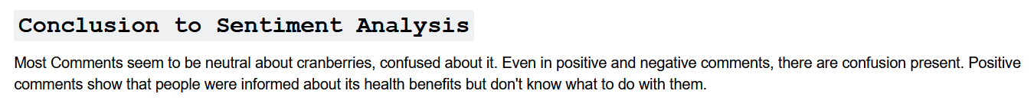

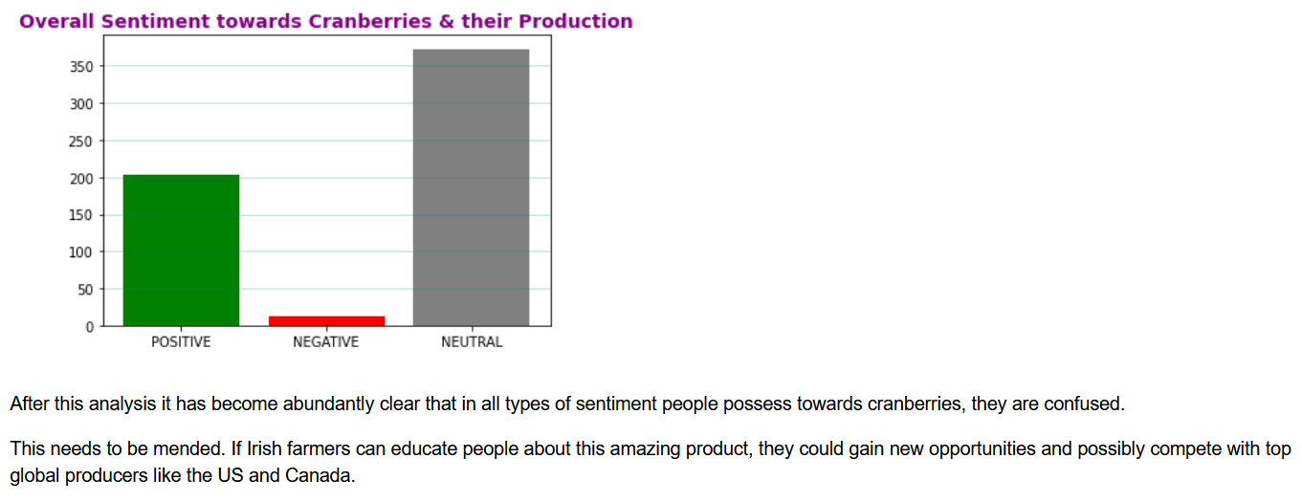

# Modelling

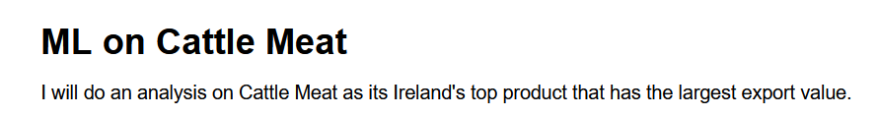

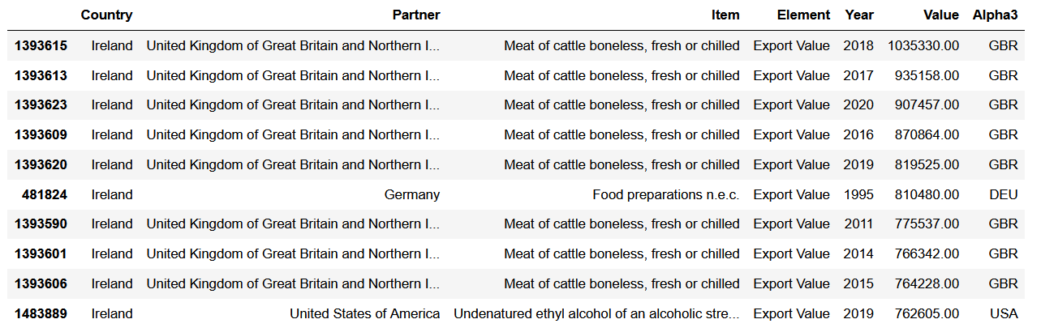

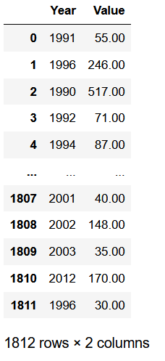

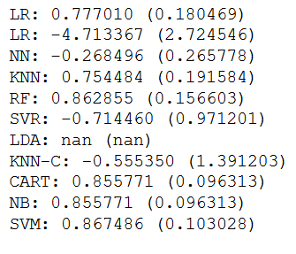

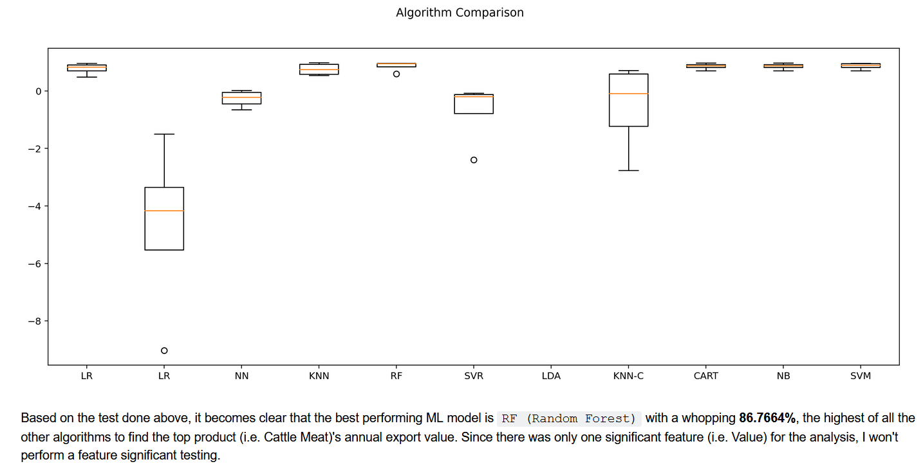

# Conclusion

The analysis seems to be overall positive for Ireland. Trading is forecasted to keep increasing. People have a positive sentiment towards Irish products. Ireland has a huge market opportunity. Ireland’s top trader partners are EU countries such as France, Belgium, Germany and Netherlands. The best product that Ireland is trading currently is the Cattle Meat with having the most export value.

There has been numerous challenges whilst doing this project but it was a rewarding one. With the new EU CAP there is a greater support for Irish farmers to excel in the agricultural sector.

# Project Challenges

* Time constraints
* Data size, Data Understanding & formatting

# Appendix

## FAOSTAT Licensing

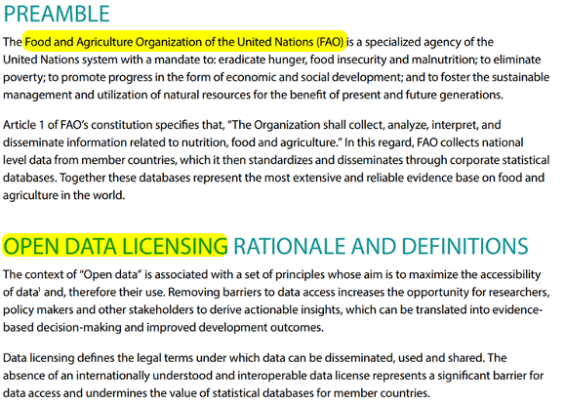

**Source**: [*www.fao.org/3/ca7570en/ca7570en.pdf*](https://www.fao.org/3/ca7570en/ca7570en.pdf)

## FAOSTAT Terms of use

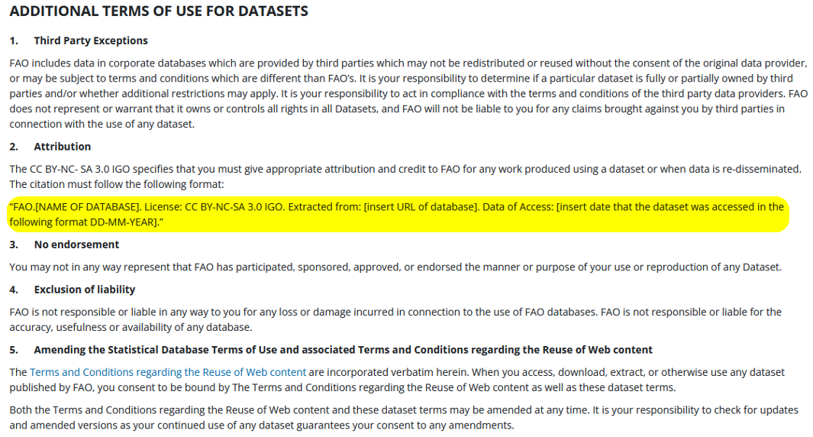

**Source:** *https://www.fao.org/contact-us/terms/db-terms-of-use/en/*

## FAOSTAT Terms & Conditions

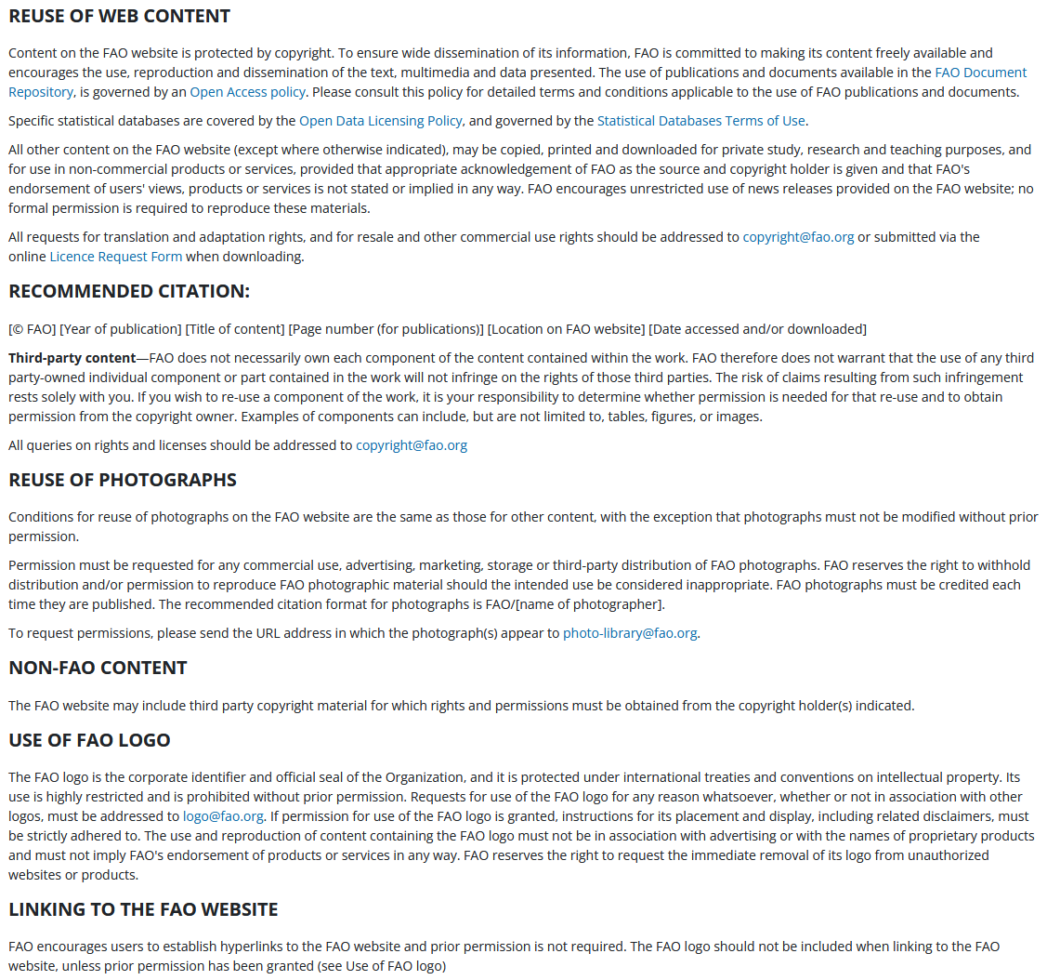

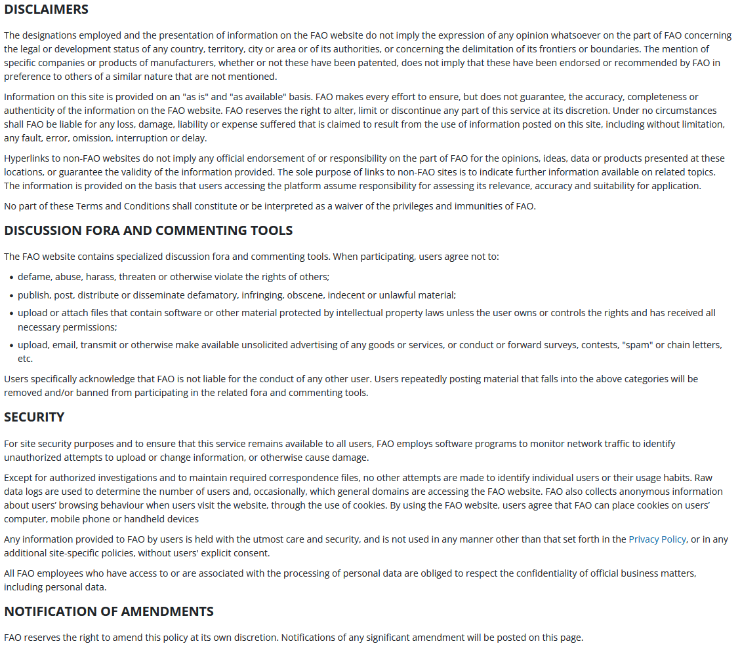

**Source:**[*www.fao.org/contact-us/terms/en/*](https://www.fao.org/contact-us/terms/en/)

## Global Reliance on Ukraine

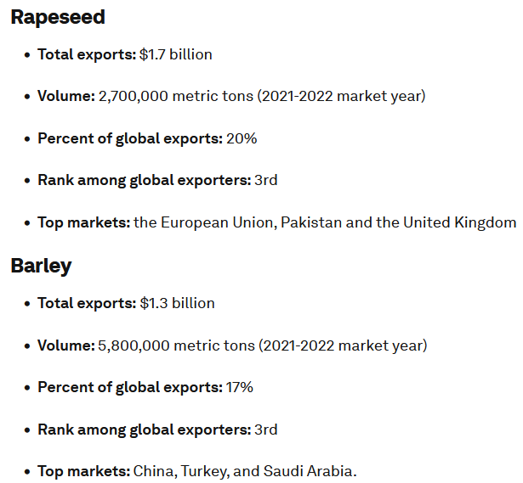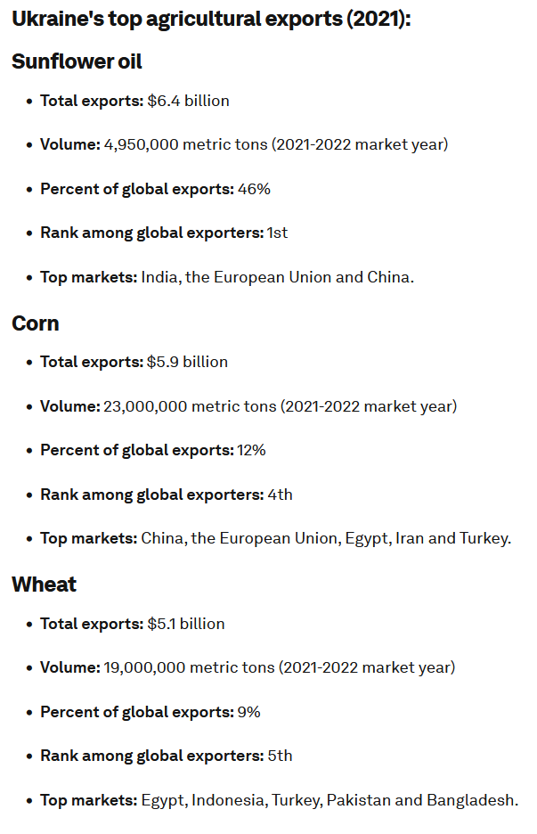

### Wheat

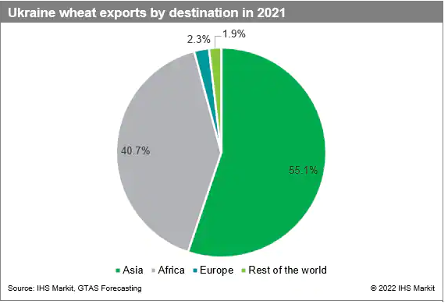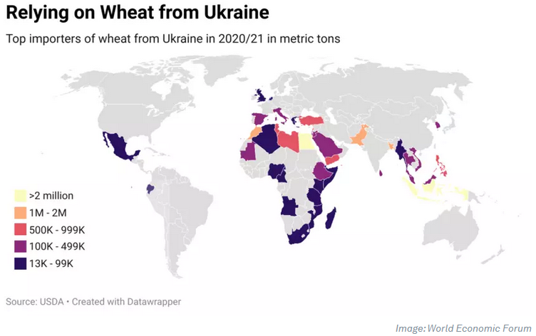

**Source:** *https://www.weforum.org/agenda/2022/07/ukraine-s-food-exports-by-the-numbers/*

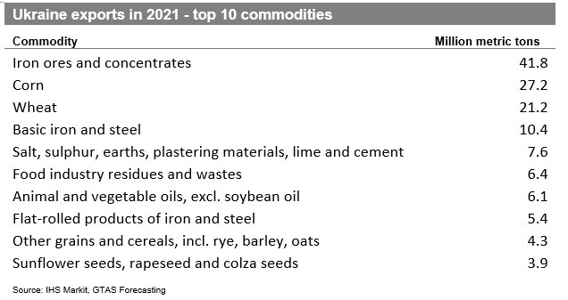

### Grains

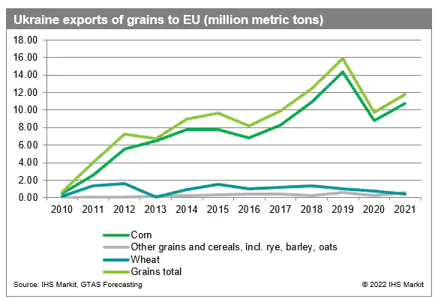

### Sunflower Oil

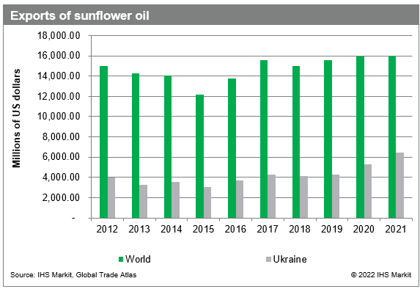

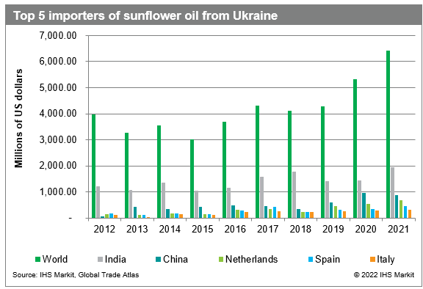

**Source**: *https://www.spglobal.com/marketintelligence/en/mi/research-analysis/ukraine-agriculture-exports-what-is-at-stake.html*

# Harvard Referencing

Bhandari, P. (2022). *Inferential Statistics | An Easy Introduction & Examples.* Available at: <https://www.scribbr.com/statistics/inferential-statistics/> (Accessed 04/01/2023).

Brand 24 (2023). *What is sentiment analysis? An ultimate guide for 2023.* Available at:

<https://brand24.com/blog/sentiment-analysis/> (Accessed 05/01/2023).

Conjointly (2023). *Inferential Statistics.* Available at: <https://conjointly.com/kb/inferential-statistics/> (Accessed 04/01/2023).

Cue Math (2023). *Inferential Statistics.* Available at: <https://www.cuemath.com/data/inferential-statistics/> (Accessed 04/01/2023).

Java T Point (2023). *Machine Learning Models.* Available at: <https://www.javatpoint.com/machine-learning-models> (Accessed 06/01/2023).

Koehrsen, W. and Whitfield, B. (2022). *The Poisson Process and Poisson Distribution, Explained.* Available at: <https://builtin.com/data-science/poisson-process> (Accessed 03/01/2023).

Microsoft (2021). *What is a machine learning model?* Available at: <https://learn.microsoft.com/en-us/windows/ai/windows-ml/what-is-a-machine-learning-model> (Accessed 06/01/2023).

Monkey Learn (2023). *Sentiment Analysis: A Definitive Guide.* Available at: <https://monkeylearn.com/sentiment-analysis/> (Accessed 05/01/2023).

Qualtrics (2023). *What is sentiment analysis and how to use it?* Available at: <https://www.qualtrics.com/uk/experience-management/research/sentiment-analysis/> (Accessed 05/01/2023).

Ray, S. (2017). *Commonly Used Machine Learning Algorithms (With Python and R Codes).* Available at: <https://www.analyticsvidhya.com/blog/2017/09/common-machine-learning-algorithms/> (Accessed 06/01/2023).

Routledge, R. (2023). *Poisson Distribution.* Available at: <https://www.britannica.com/topic/uniform-distribution-statistics> (Accessed 03/01/2023).

Science Direct (2023). *Inferential Statistics.* Available at: <https://www.sciencedirect.com/topics/medicine-and-dentistry/inferential-statistics> (Accessed 04/01/2023).

Science Direct (2023). *Poisson Distribution.* Available at: <https://www.sciencedirect.com/topics/mathematics/poisson-distribution> (Accessed 03/01/2023).

Selvaraj (2022). *8 Machine Learning Models Explained in 20 Minutes.* Available at: <https://www.datacamp.com/blog/machine-learning-models-explained> (Accessed 06/01/2023).

Shin, T. (2020). *All Machine Learning Models Explained in 6 Minutes.* Available at: <https://towardsdatascience.com/all-machine-learning-models-explained-in-6-minutes-9fe30ff6776a> (Accessed 06/01/2023).

Stat Trek (2023). *Poisson Distribution.* Available at: <https://stattrek.com/probability-distributions/poisson> (Accessed 03/01/2023).

Statistics How To (2023). *Inferential Statistics: Definition, Uses.* Available at: <https://www.statisticshowto.com/probability-and-statistics/statistics-definitions/inferential-statistics/> (Accessed 04/01/2023).

Tech Target (2023). *Sentiment Analysis (Opinion Mining).* Available at: <https://www.techtarget.com/searchbusinessanalytics/definition/opinion-mining-sentiment-mining> (Accessed 05/01/2023).

Towards Data Science (2023). *Sentiment Analysis: Concept, Analysis and Applications.* Available at: <https://towardsdatascience.com/sentiment-analysis-concept-analysis-and-applications-6c94d6f58c17> (Accessed 05/01/2023).

Turney, S. (2022). *Poisson Distributions | Definition, Formula & Examples.* Available at: <https://www.scribbr.com/statistics/poisson-distribution/> (Accessed 03/01/2023).